ISTM 637- 603

Data Warehousing

Spring 2018

Project- BikeMS

*May 2, 2018*

Group Bikalytics

Divyesh Batra

Harikrishnan Subramanyan

Nupur Sinha

Tanushree Kothari

Tsai Mei Chen



Table of Contents

1. Executive Summary 2

2. Introduction 3

3. Business Case for Data Warehouse 4

4. Data Warehouse Architecture 7

4.1 DWH Architecture 7

4.2 Why Kimball 7

5. Dimensional Data Design 8

5.1 Data Warehouse Bus Matrix 9

6. Data Extraction, Transformation, & Loading (ETL) 10

6.1 SSIS Packages and OLAP Cubes 10

7. Business Intelligence (BI) Reports 27

7.1 Corporate Acquisition Analysis Reports 28

7.2 Digital/Social Acquisition Reports 40

7.3 Other Insights 51

8. Metadata Documentation 54

8.1 External data sources metadata 54

8.2 Dimensions metadata 55

8.3 Facts metadata 59

9. Appendices 67

10. References 70

11. Glossary 71

12. Peer Evaluation 73

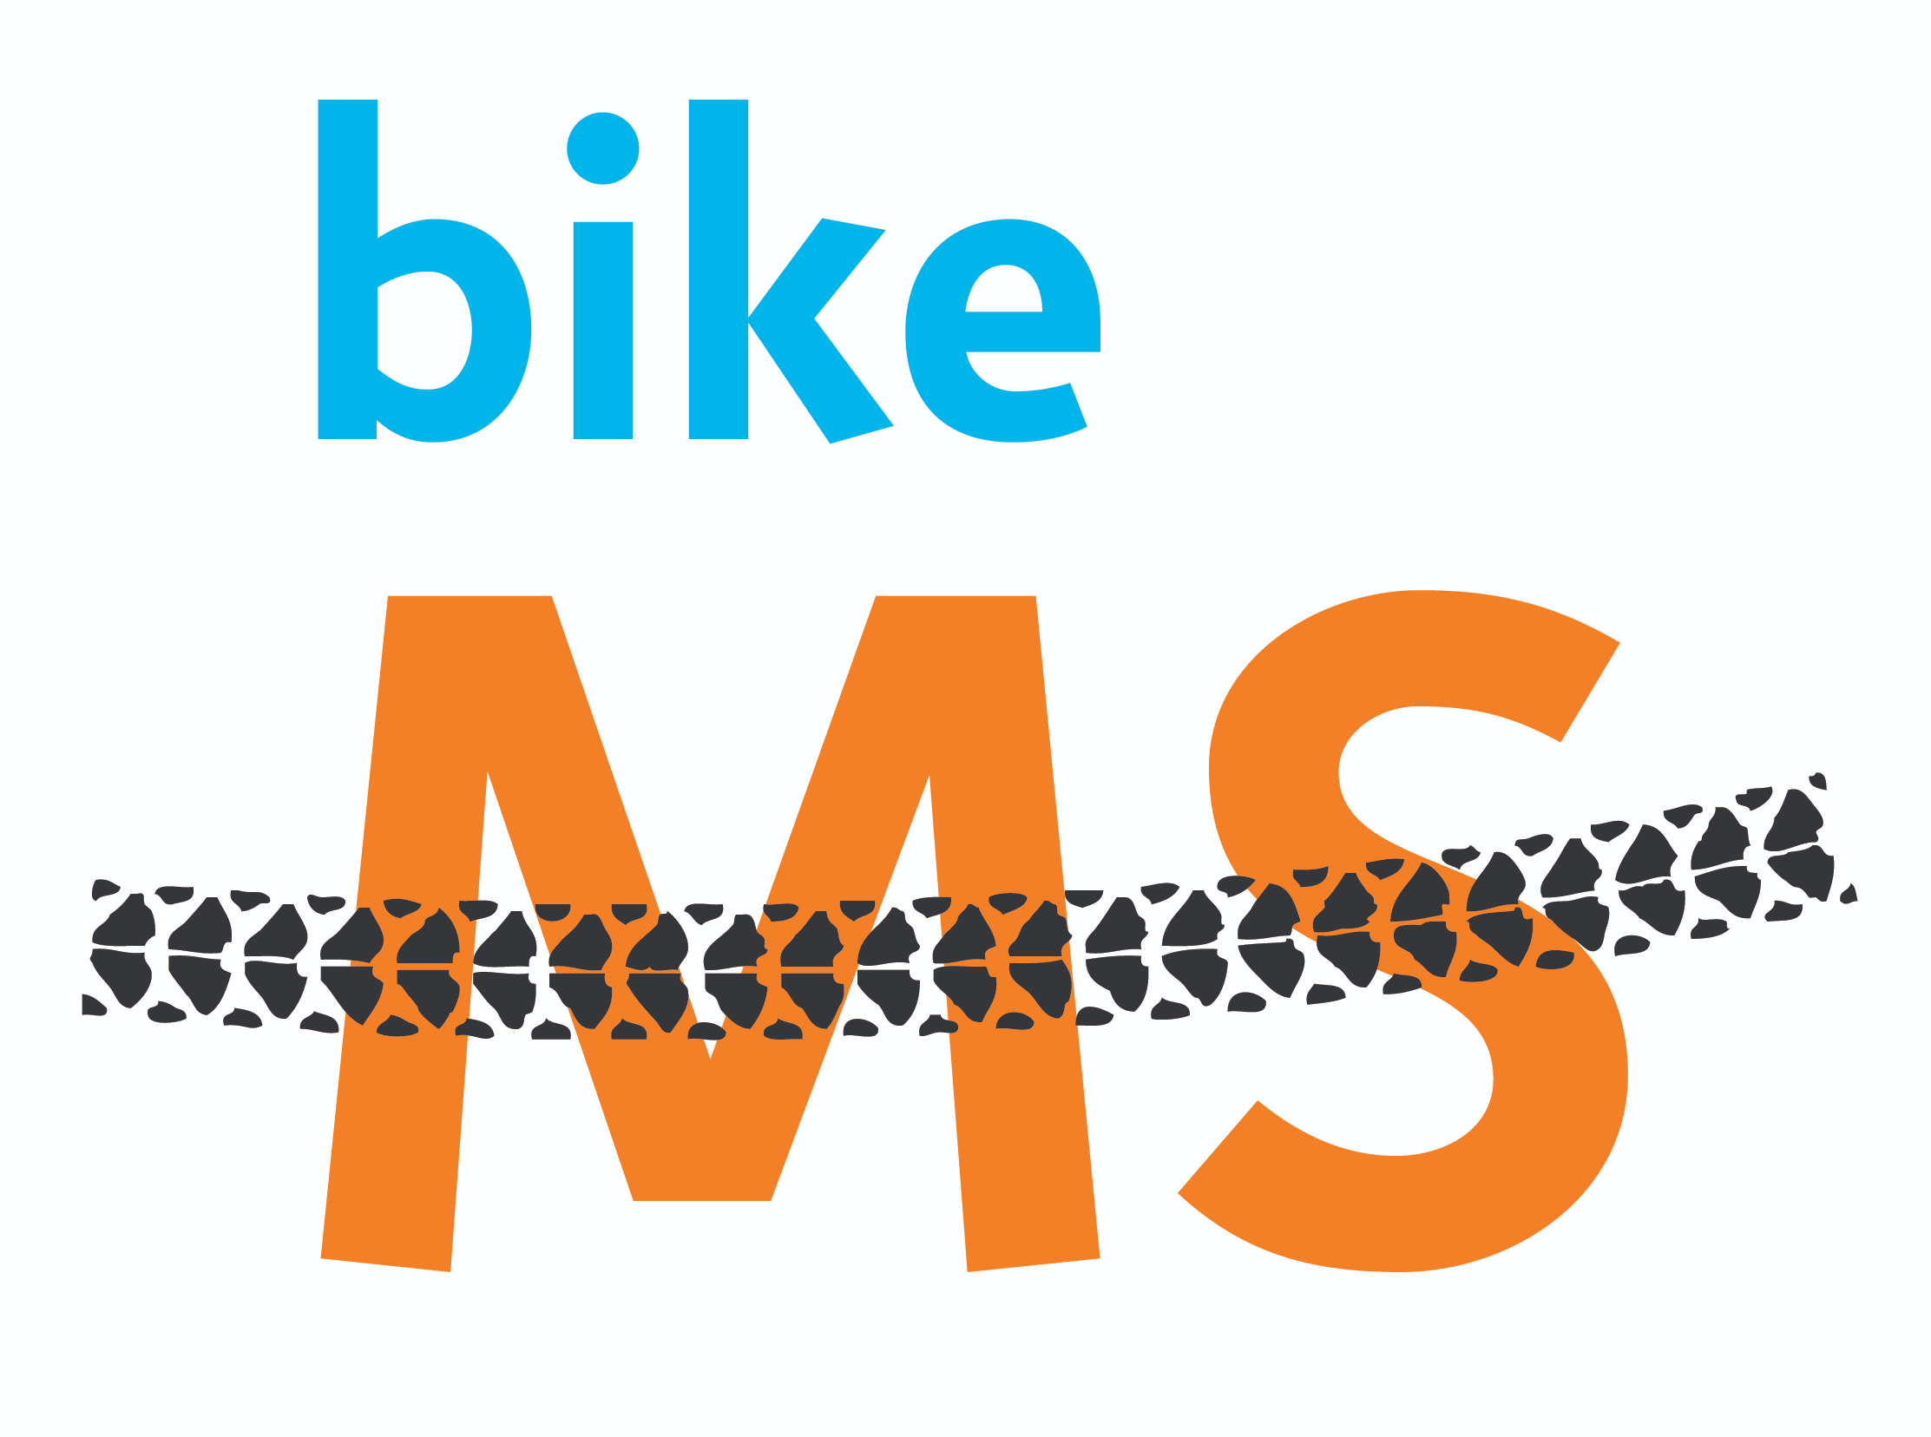

*Source:* [*http://main.nationalmssociety.org/site/PageNavigator/BIKE_HOM_splash.html*](http://main.nationalmssociety.org/site/PageNavigator/BIKE_HOM_splash.html)

# 1. Executive Summary

Being the largest charity cycling fundraising campaign, Bike MS has attracted over 70,000 participants to engage in and has raised $68 million.[1] However, to raise awareness of multiple sclerosis (MS) and to materialize National Multiple Sclerosis Society’s vision of a world free of MS, Bike MS needs more funding and participants. Bike MS therefore set a goal for 2018’s events: 80,572 riders and 6,489 teams.

To fulfill the goal, we have to possess a thorough understanding of participant and donor behavior. By spotting growth opportunities and determining competitors’ weakness, we can develop effective marketing strategy and make better business decisions. Hence, we implement a data warehouse platform using Kimball’s bottom-up approach to support the business intelligence solution. We also design a star schema to organize the donation, participation, event, and advertising information.

The results show that energy, financial, and IT industries had the strongest involvement. Among all industries, engineers and managers tend to donate more money. They also show that small events attract more participants than medium and big events. In addition, the majority of the donors are participants that have no connection with MS. Moreover, the results show ADA – Tour de Cure, Best Buddies, and JDRF are the main competitors of Bike MS. To summarize we suggest MS Bike should hold small or medium events and develop a marketing plan targeting participants and donors meet the following criteria:

1. Participants work in energy, financial, or IT industry.
2. Participants with engineering, executive, or management background.
3. Participants who have no connection with MS or have friends that have MS.
4. Participants in Houston and Philadelphia.
5. Participants using fundraising tools such as Facebook, mobile app, and web page.

# 2. Introduction

Founded in 1946, National Multiple Sclerosis Society (NMSS) is a non-profit organization based in New York.[2] The organization funds research and programs helping people with multiple sclerosis (MS) and their families.

MS is disabling disease that attacks the central nervous system. Symptoms range widely. In milder cases, there may be numbness in the limbs. Severe cases may involve paralysis or vision loss. [3] Most people with MS are diagnosed between the ages of 20 and 50, with at least two to three times more women than men being diagnosed with the disease. [4] Although there are a number of hypotheses for the causes of MS, such as Epstein - Barr virus (EBV) and vitamin D deficiencies, the exact cause has not yet been discovered by scientists.[5] According to NMSS, nearly one million people in the United States have MS, and around 10,000 new cases are diagnosed each year.[6]

The mission of NMSS is “people affected by MS can live their best lives as we stop MS in its tracks, restore what has been lost and end MS forever.” To fulfill this mission, in 2016, NMSS devoted more than $100 million to connect approximately one million people affected by MS to the connections, information and resources they need. NMSS also invested $42 million to support more than 380 new and ongoing research projects around the world.[7] Moreover, NMSS hold fundraising events each year, such as Walk MS, Bike MS, and MuckFest to support people living with MS and to bring people closer to a world free of MS.

# 3. Business Case for Data Warehouse

The current business intelligence needs of Bike MS event revolve around two main categories: **Corporate Acquisition** and **Digital/Social Acquisition**. As described on the Bike MS website, the data set is provided in the form of spreadsheets. Based on the data provided, an analysis can be conducted in the following ways:

1.      **Using current excel sheets to analyze data**

2.       **Using RDBMS approach to analyze data**

3.       **Using a data warehouse approach to analyze data**

Based on the analysis done by group BikeAlytics, the approach of designing a data warehouse to analyze data is the best approach pertaining to the case. A detailed explanation of not choosing the other two approaches and selecting a data warehouse approach is presented below:

**Drawbacks of using current Excel Sheets to Analyze Data:**

**Assertion 1**: With a dataset of around 273.5 MB and an aggregated record size of 4,289,121 rows, the drawback of analyzing data using Excel is that it presents a single view of raw data, all at once which is very difficult to visualize for the senior management of BikeMS.

**Reasoning for single-view of raw data**:  Fields like ‘Internal Event Name’, ‘Fiscal Year’, ‘Event ID’ are repeatedly used in various spreadsheets, which makes the data redundant and difficult to comprehend what is important and what is not important to answer business intelligence questions. Thus, generating analytics revolving around multiple spreadsheets with redundant data is not a reliable way to gather insights within a business and predicting future trends to gain competitive advantage.

**Assertion 2:** As the Bike MS team needs to predict future trends based on data gathered during fiscal year 2015-2017, it is imperative to link data from external data sources or other competitors to gain insights into the prevalent market trends. In excel, it becomes a painstaking task to clean data which is not only time-consuming, but also has a potential to introduce errors while cleansing of data.

**Reasoning for Non-integrity of data**: Currently in the data set provided, there are a number of records where there are spelling mistakes such as ‘Constituents’ is misspelled as ‘Constituats’, ‘Female’ gender is wrongly spelled as ‘Feale’ etc. Thus, with the limited import abilities spreadsheets offer, processing times can often be very slow, and integrity of data is compromised.

**Assertion 3**: As we have to maintain historical records for all the returning participants and corporate teams to Bike MS event, editing the data in same cells lead to permanent loss of historical information and thus results in a potential gap in the analysis.

**Reasoning for Historical Data loss**: Such huge data loss creates problems in data analysis and auditing, making it quite tough to identify trends and evaluate performance without relying on multiple copies of the same spreadsheet from different periods.

**RDBMS vs Data Warehouse Approach**

In order to understand the difference between a database and a data warehouse, we must understand that a data warehouse is used for analytical purposes and a database is a repository of data used as a backing data storage for some specific application or set of applications.

For Bike MS event, our main purpose is to analyze data collected during the fiscal years 2013-2017 in order to improve corporate acquisition strategy and digital acquisition strategy.

1. An RDBMS System stores historical information in order to create backups of data, mainly for performance reasons. On the other hand, a data warehouse created for Bike MS allows us to measure facts like ‘**Total Revenue Collected per Event**’ during years 2013-2017 and seek opportunities where further fundraising involvement could have been made for more profits. Owing to denormalized data in data warehouse, simpler joins can be made on tables to reduce the response time for analytical queries. Moreover, insights in specific business area can be answered by specific data marts. For example, in order to check for donations made by various industries, we just need to check donations fact table that has all the measures related to donations.

2. In Data warehouse, we can store additional information from external sources that is bought or captured elsewhere to complement the information that is generated and stored by the internal database system. For example, in order to answer **greatest growth opportunities for new corporate teams**, we have made use of external data sources that yield results for all the corporate organizations that have donated in other events like **Best Buddies, Pedal the Cause, American Cancer Society** etc. and used this additional information to compare donations made in Bike MS events by organizations in the same industry (*energy, engineering, healthcare etc.*). The analysis can be easily shown in the form of reports to senior leadership who can target potential industries to maximize profits in BIKE MS 2018 event.

3. Similarly, for digital acquisitions, data from external sources like Google Analytics, Social Media platforms like Facebook, Instagram etc. can be integrated into the data warehouse that provides a quantitative measure to calculate the **cost of clicks-per-ads** (CPA) over the years which clearly answers the **greatest opportunities for digital marketing investments**. For example, based on our analysis, Bike MS should focus on markets like Houston, Philadelphia, NYC, Minneapolis, Denver and Dallas with more focus on video assets and market-specific creatives for Bike MS. Such an analysis is not possible using a traditional RDBMS approach.

4. In order to answer BI questions for Bike MS event, we would have to take into account the grain of information. In data warehouse, we can easily store different versions of the same information, using different structures to compose and access the information. For example, in order to answer BI needs like **corporate acquisitions relevant for biggest events**, we can answer the BI need using ‘event-level’ data and on the other hand, in order to answer BI needs like **what participant behavior drives fundraising**, we can use databases on ‘participant-level’. Hence, the grain of information can significantly vary which supports multiple sets of same data (denormalized data) for data analysis.

Thus, a data warehouse enables us to perform many types of analysis: Descriptive (*what has happened*), Diagnostic (*why it happened*), Predictive (*what will happen*), and Prescriptive (*what to do about it*).

Thus, the future of BikeMS depends on the ability to use the massive amounts of data available to drive better quality at a lower cost. If the senior leadership cannot perform analytics to make sense of the data collected over the years, they will have trouble improving quality and costs, and won’t succeed against the prevalent competition in the cycling charity domain. Hence, designing a data warehouse (Online Analytical Processing) using Kimball’s approach is of paramount importance.

# 4. Data Warehouse Architecture

## 4.1 DWH Architecture

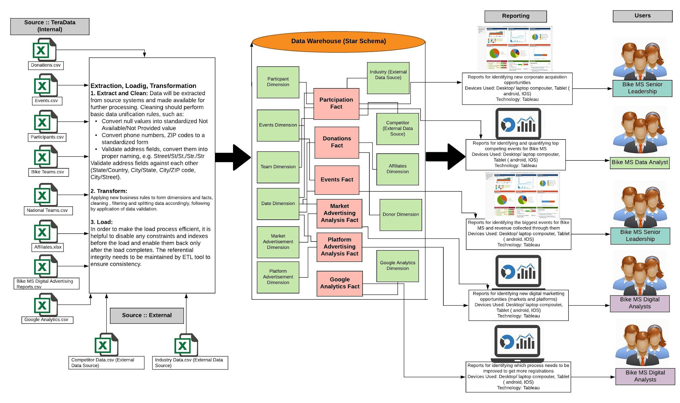

## 4.2 Why Kimball

As NMSS wishes to uncover growth opportunities and perform detailed analysis of their company’s performance, implementing a data warehouse solution using **Kimball’s bottom-up approach** would be most suitable to address their BI needs. It will provide a faster solution, facilitate better coordination and strategic decision-making in the future. A star schema where facts are connected to multiple dimensions would be suitable as it would provide faster access to queries (BI needs).

Kimball’s approach would be feasible for NMSS to implement as initially only a single subject area would be developed in phase one. In the subsequent phases, more subject areas would be worked upon, eventually creating the entire data warehouse. This approach will also allow them to develop the skills and techniques required for data warehousing in a much lower risk environment, as they go along the way in an incremental fashion.

Other Benefits of Kimball’s approach for NMSS:

* Quick ROI
* Building the data warehouse will take less time
* Initial cost would be low, and each subsequent phase also will cost the same
* Shorter start up time during initial set up as only a single data mart (subject area) would be designed and developed at a time

# Dimensional Data Design

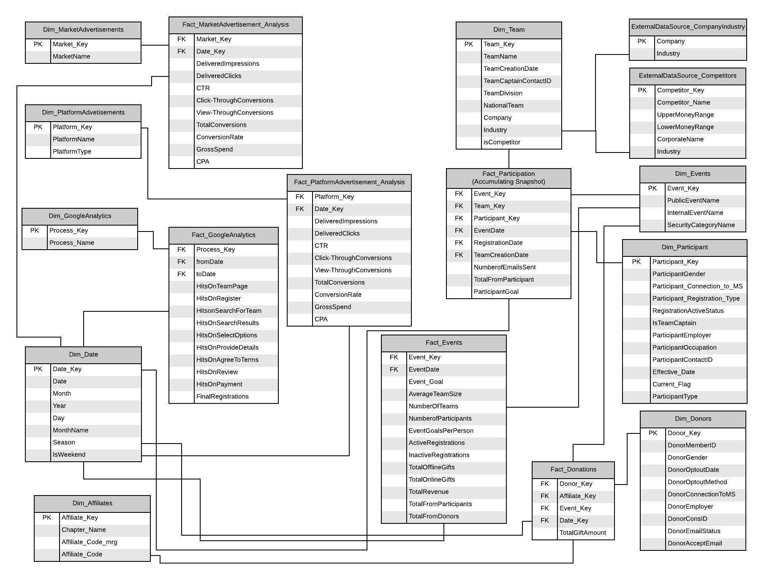

## 5.1 Data Warehouse Bus Matrix

|  |  |  |  |  |  |  |  |  |  |
| --- | --- | --- | --- | --- | --- | --- | --- | --- | --- |
| **Business Processes** | **Dimensions** | | | | | | | | |
| Team | Event | Participant | Date | Donors | Affiliates | Google Analytics | Platform Advertisements | Market Advertisements |
| Events Analysis |  | x |  | x |  |  |  |  |  |
| Donations Analysis |  | x |  | x | x | x |  |  |  |
| Participants Analysis | x | x | x | x |  |  |  |  |  |
| Platform Advertisements Analysis |  |  |  | x |  |  |  | x |  |
| Market Advertisements Analysis |  |  |  | x |  |  |  |  | x |
| Google Analytics |  |  |  | x |  |  | x |  |  |

# Data Extraction, Transformation, & Loading (ETL)

The SSIS packages developed, along with the data flow diagram are listed below:

## 6.1 SSIS Packages and OLAP Cubes

* + - 1. **Participations:** This package is used to load the data from the csv source file ‘2013-2017 Bike MS Participants’ into a staging table. Further, the data is cleaned and filtered to remove bad data, finally transformed using the data conversion transformation to create a participant dimension.

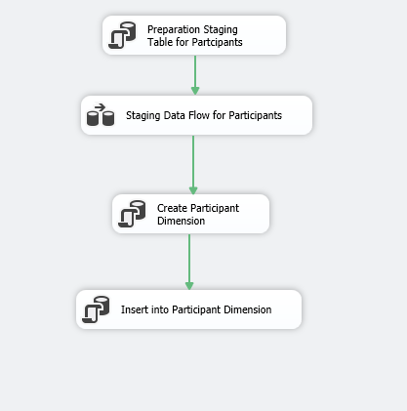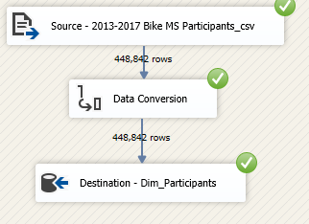

2. **Events:** This package is used to load the data from the csv source file ‘2013-2017 Events’ into a staging table. Further, the data is cleaned and filtered to remove bad data. As mentioned in the case, the rows having event date in the source file as null is test data and therefore is removed during cleaning and is not being considered for analysis. The data is finally transformed using the data conversion transformation to create an event dimension.

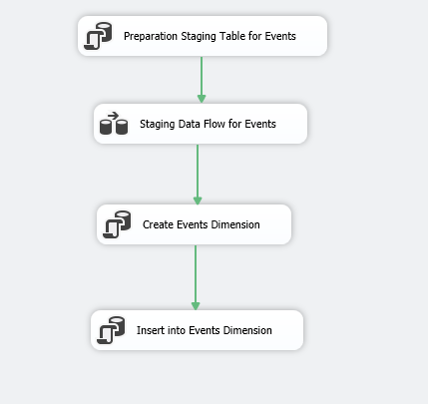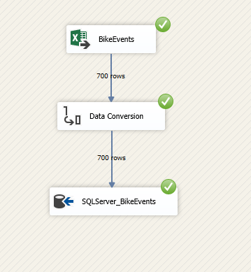

3. **Affiliates:** This package is used to load the data from the csv source file ‘Affiliate_Codes’ into a staging table. Further, the data is cleaned and filtered to remove bad data. The data is finally loaded into the target table to create an affiliate dimension.

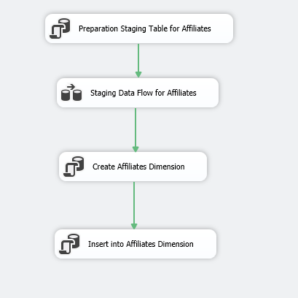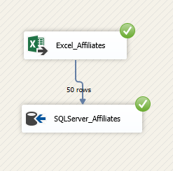

4. **Donations:** This package is used to load the data from five csv source files - 2013 to 2017 Donations into a single staging table. Further, the data is cleaned and filtered to remove bad data. The data is finally loaded into the target table to create a donor dimension.

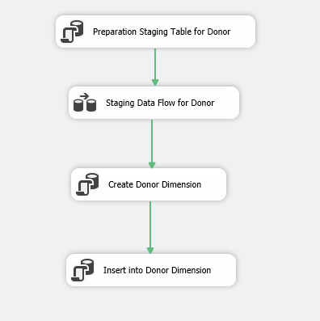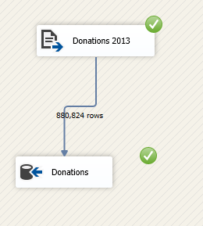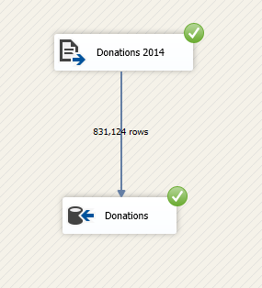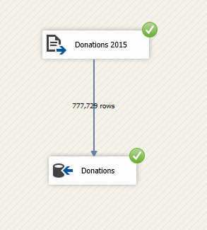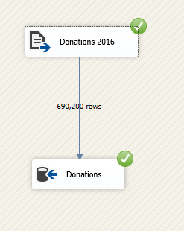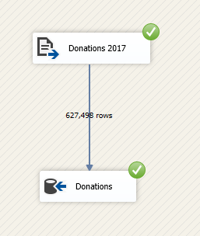

5. **Teams:** This package is used to load the data from csv source file - ‘2013-2017 Teams’ into a staging table. Further, the data is cleaned and filtered to remove bad data. The data is finally transformed using the data conversion transformation to create a team dimension.

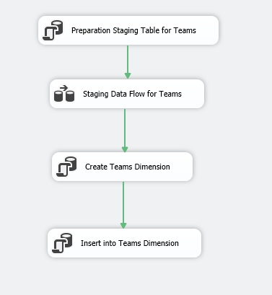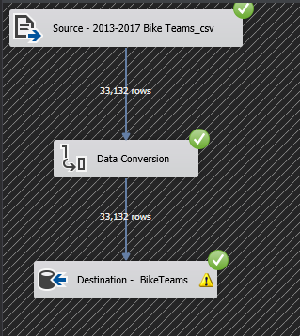

6. **Market Advertisements**: This package is used to load the data from digital marketing source files (Market Advertisements csv source file) into a staging table. Further, the data is cleaned and filtered to remove bad data. The data is finally transformed using the data conversion transformation to create a market advertisements dimension.

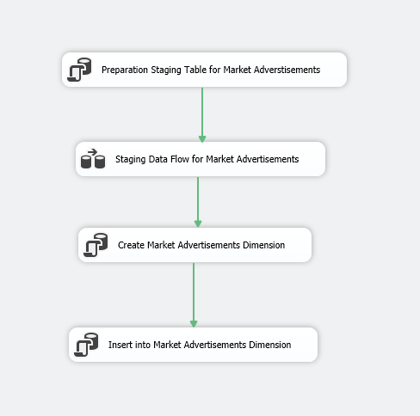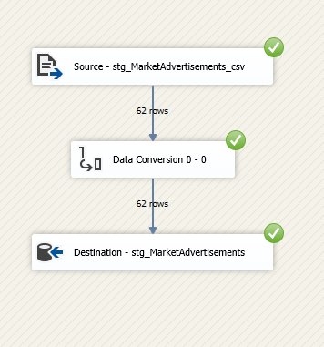

1. **Platform Advertisements**: This package is used to load the data from digital platform source files (Platform Advertisements csv source file) into a staging table. Further, the data is cleaned and filtered to remove bad data. The data is finally transformed using the data conversion transformation to create a platform advertisements dimension.

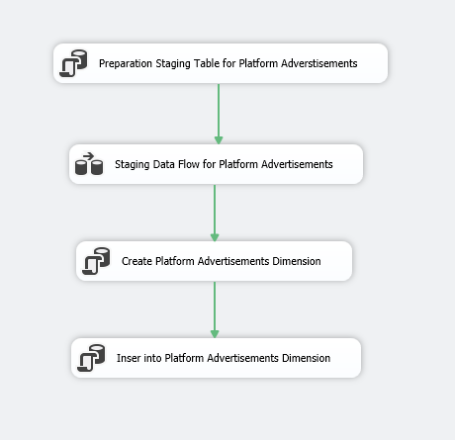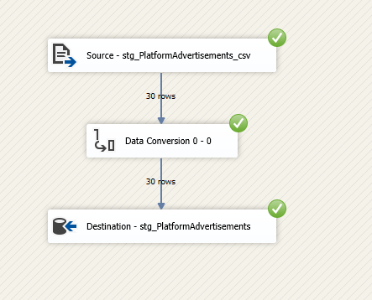

8. **Google Analytics**: This package is used to load the data from Google Analytics source files into a staging table. Further, the data is cleaned and filtered to remove bad data. The data is finally transformed using the data conversion transformation to create a google analytics dimension.

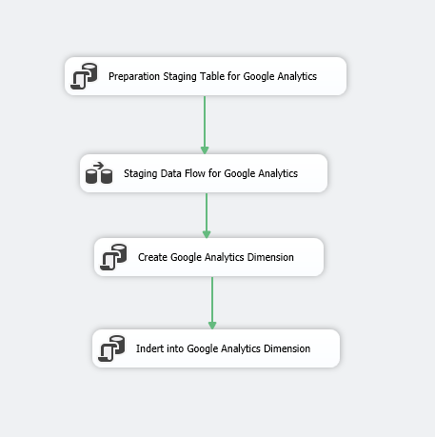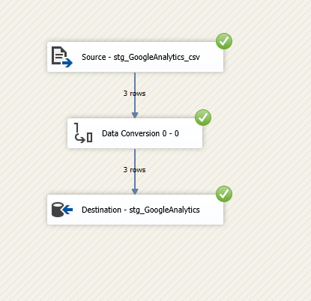

**9. Fact Donation:** This package is used to load the data to create a donation fact table by looking up for dimension keys from affiliate dimension, date dimension, event dimension and donor dimension and measures from corresponding staging tables, aggregated over the mentioned dimension keys.

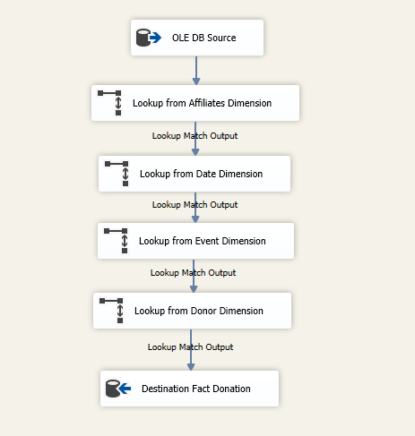

**Corresponding OLAP Cube**- This cube will be used to answer the BI questions regarding the donations.

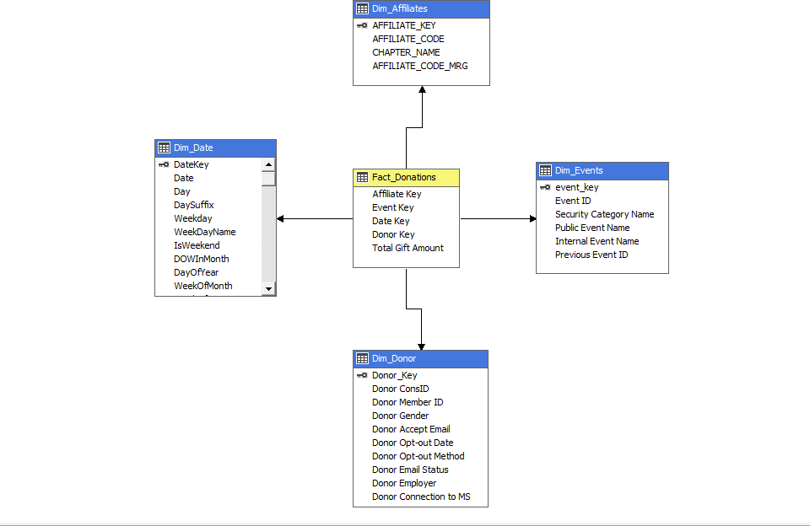

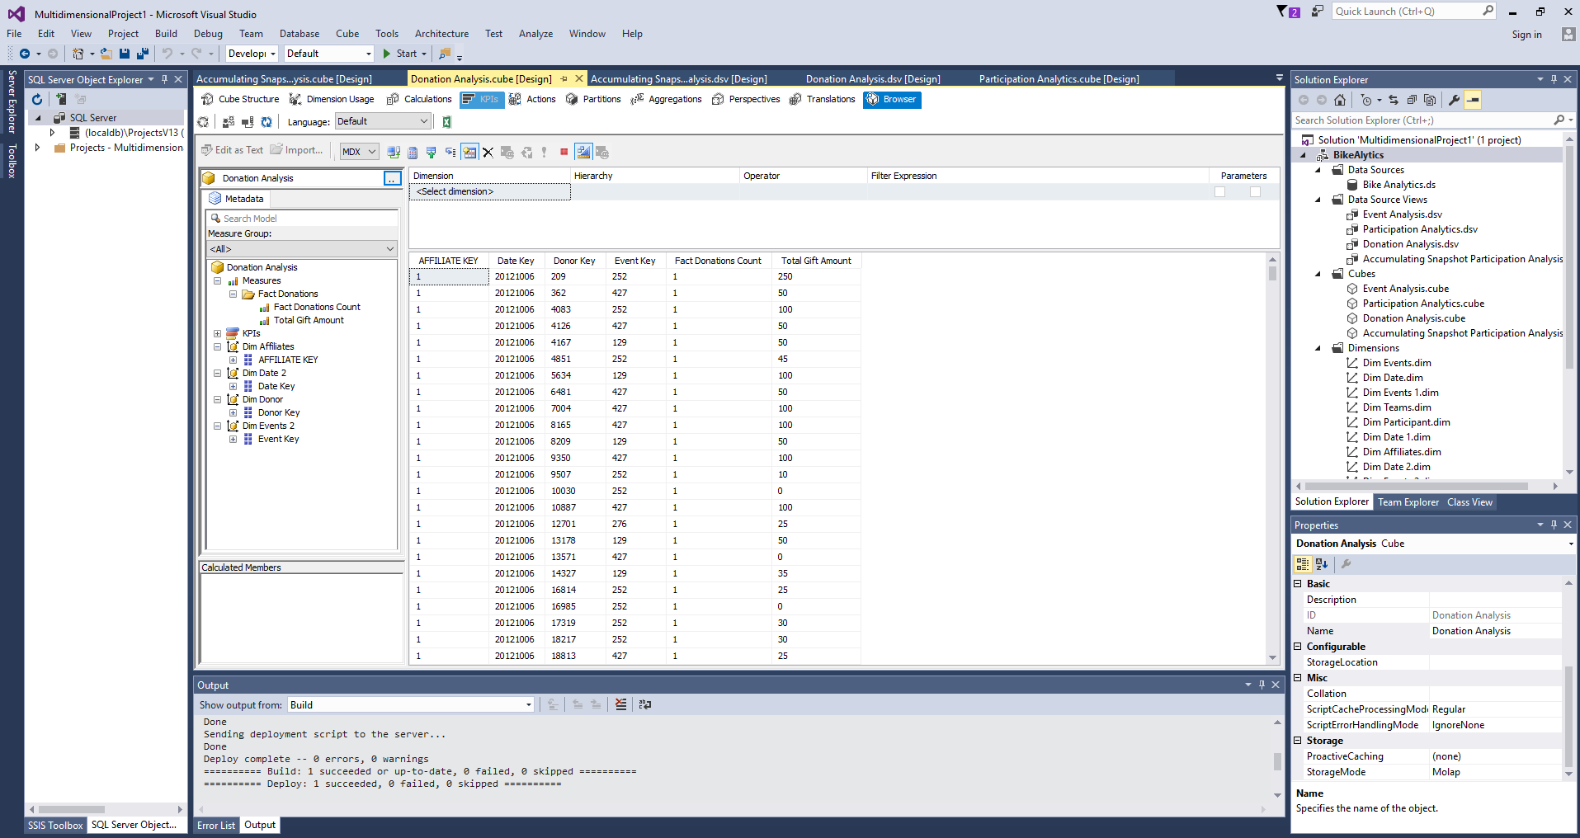

**10. Fact Participation (Accumulating Snapshot)-** This package is used to load the data to create an accumulating snapshot fact table for participation by looking up for dimension keys from team dimension, date dimension, event dimension and participant dimension and measures from corresponding staging tables, aggregated over the mentioned dimension keys.

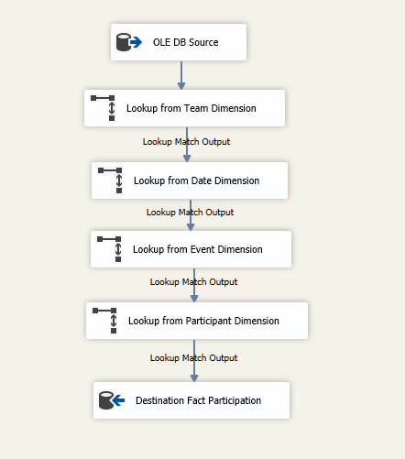

**Corresponding OLAP Cube**- This cube will be used to answer the BI questions regarding the participations in the events.

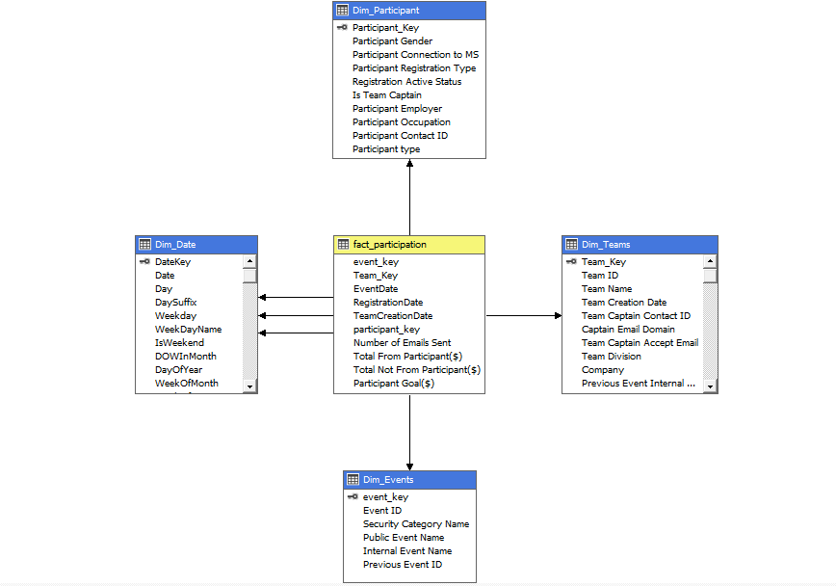

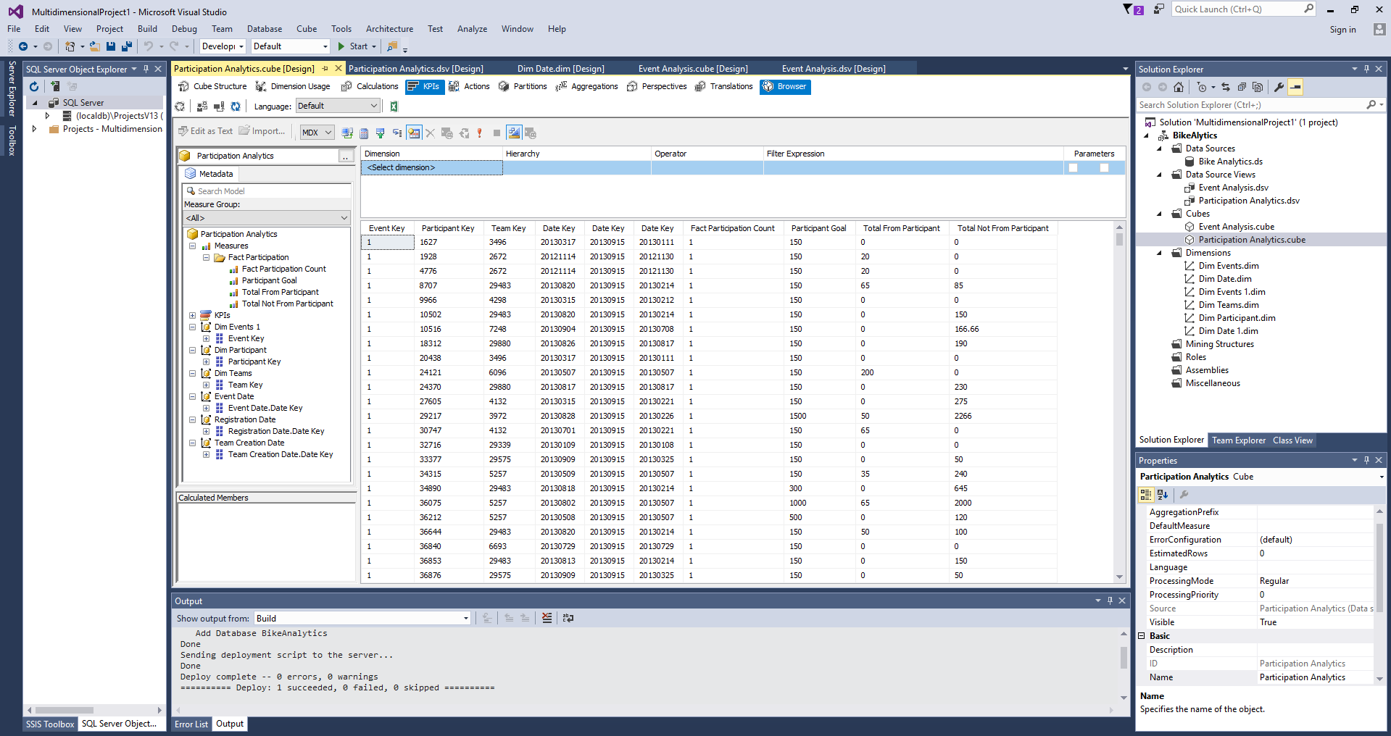

**11. Fact Market Advertisement Analysis-** This package is used to load the data to create a fact table for market advertisement analysis, by looking up for dimension keys from market advertisement dimension and date dimension, and measures from corresponding staging tables, aggregated over the mentioned dimension keys.

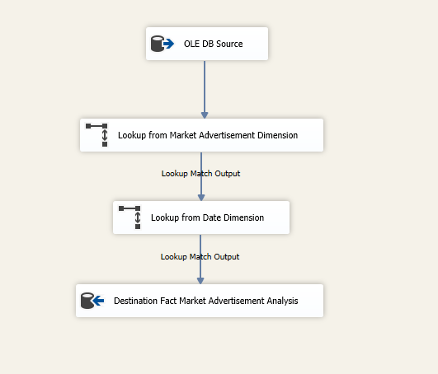

**Corresponding OLAP Cube**- This cube will be used to answer the BI questions regarding the market advertisements.

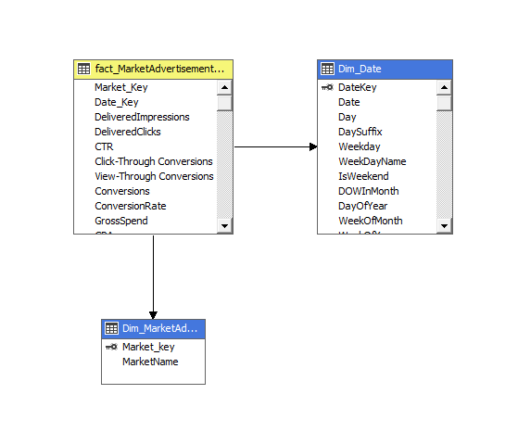

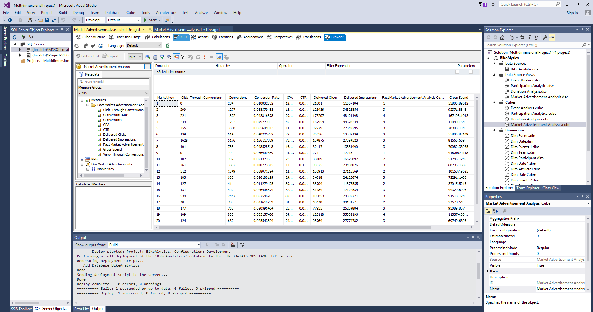

12. **Fact Platform Advertisement Analysis**- This package is used to load the data to create a fact table for platform advertisement analysis, by looking up for dimension keys from platform advertisement dimension and date dimension, and measures from corresponding staging tables, aggregated over the mentioned dimension keys.

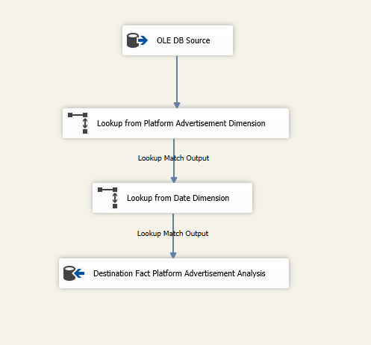

**Corresponding OLAP Cube**- This cube will be used to answer the BI questions regarding the platform advertisements.

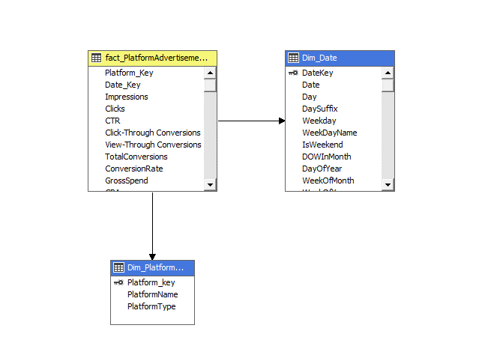

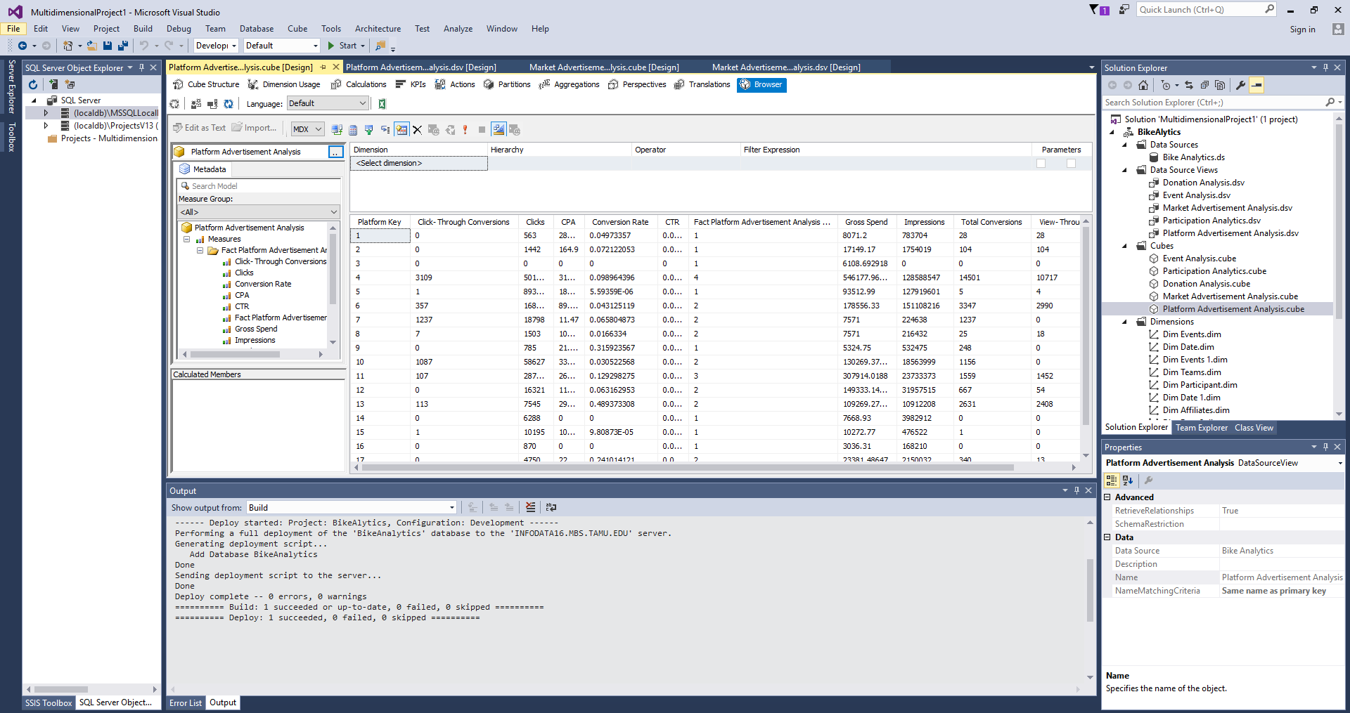

**13. Fact Events:** This package is used to load the data to create an events fact table by looking up for dimension keys from event dimension and date dimension, and measures from corresponding staging tables, aggregated over the mentioned dimension keys.

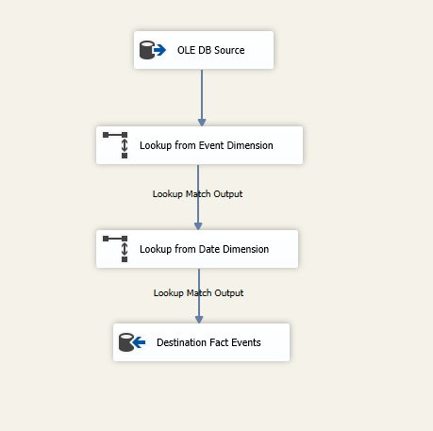

**Corresponding OLAP Cube**- This cube will be used to answer the BI questions regarding the events.

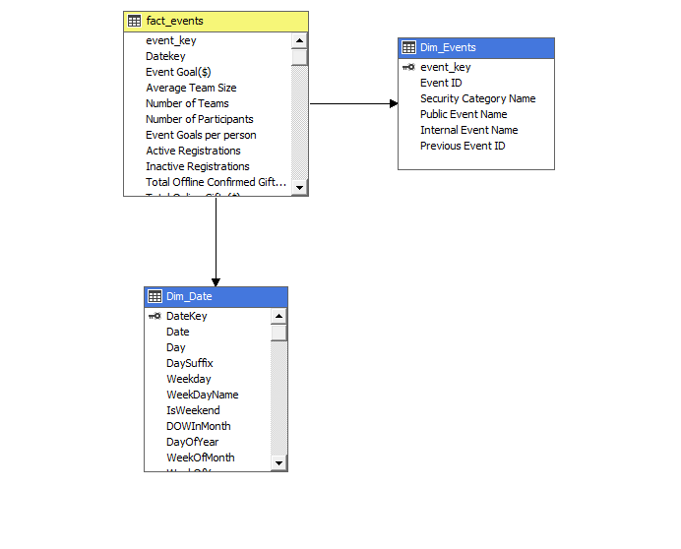

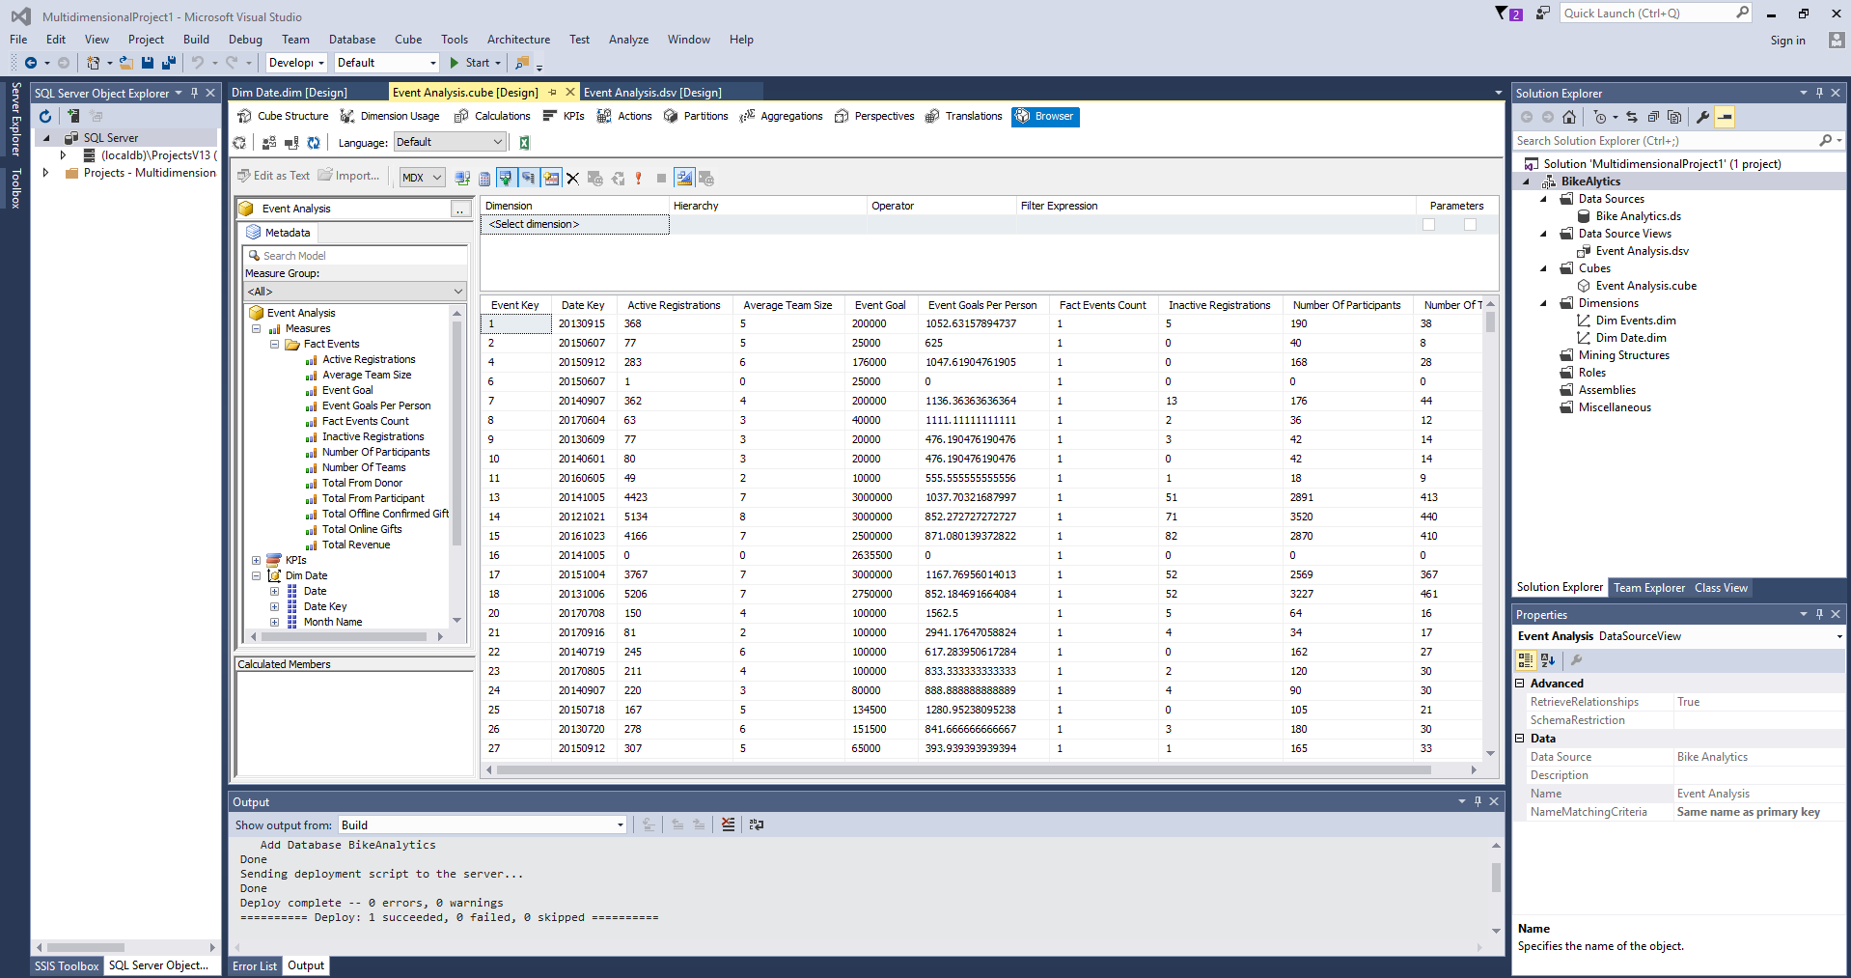

**14. Fact Google Analytics**- This package is used to load the data to create a fact table for google analytics, by looking up for dimension keys from google analytics dimension and date dimension, and measures from corresponding staging tables, aggregated over the mentioned dimension keys.

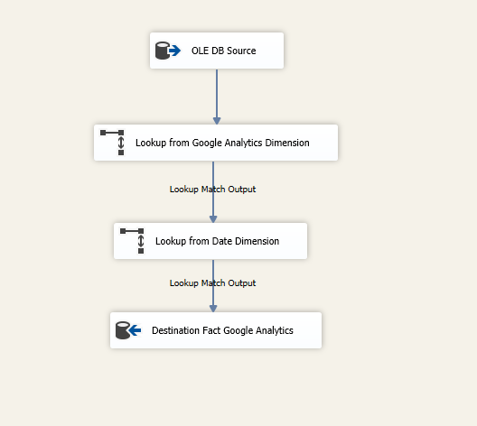

**Corresponding OLAP Cube**- This cube will be used to answer the BI questions regarding the google analytics.

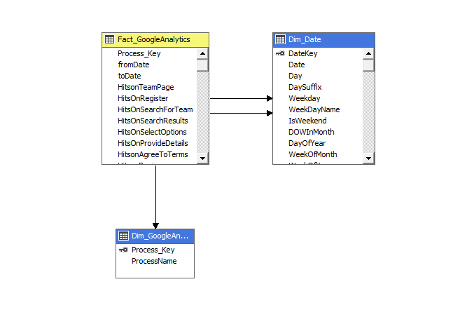

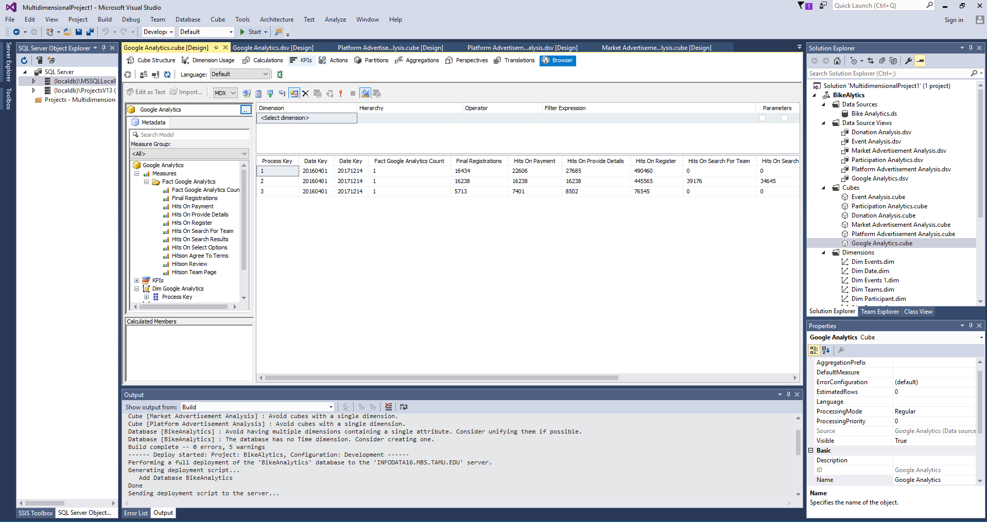

# 7. Business Intelligence (BI) Reports

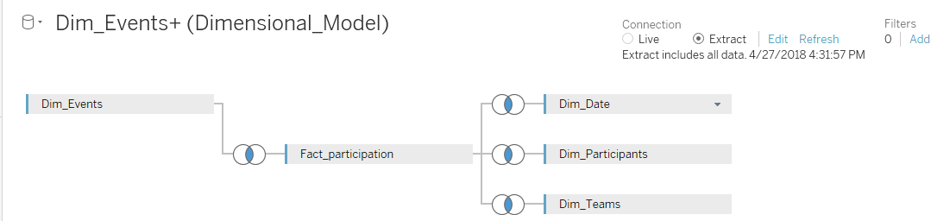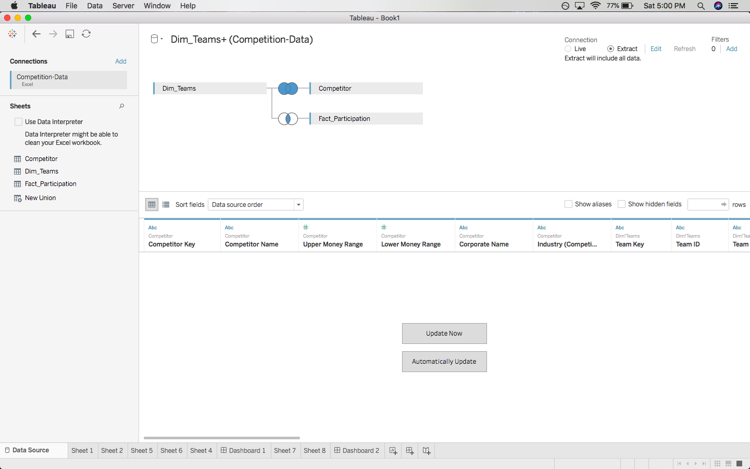

SQL server database imported in Tableau

## 7.1 Corporate Acquisition Analysis Reports

**7.1.1. Greatest growth opportunities for new corporate teams**

This report shows the donations made by companies in competing events. Companies making high donations could be potential target for NMSS’ Bike MS event.

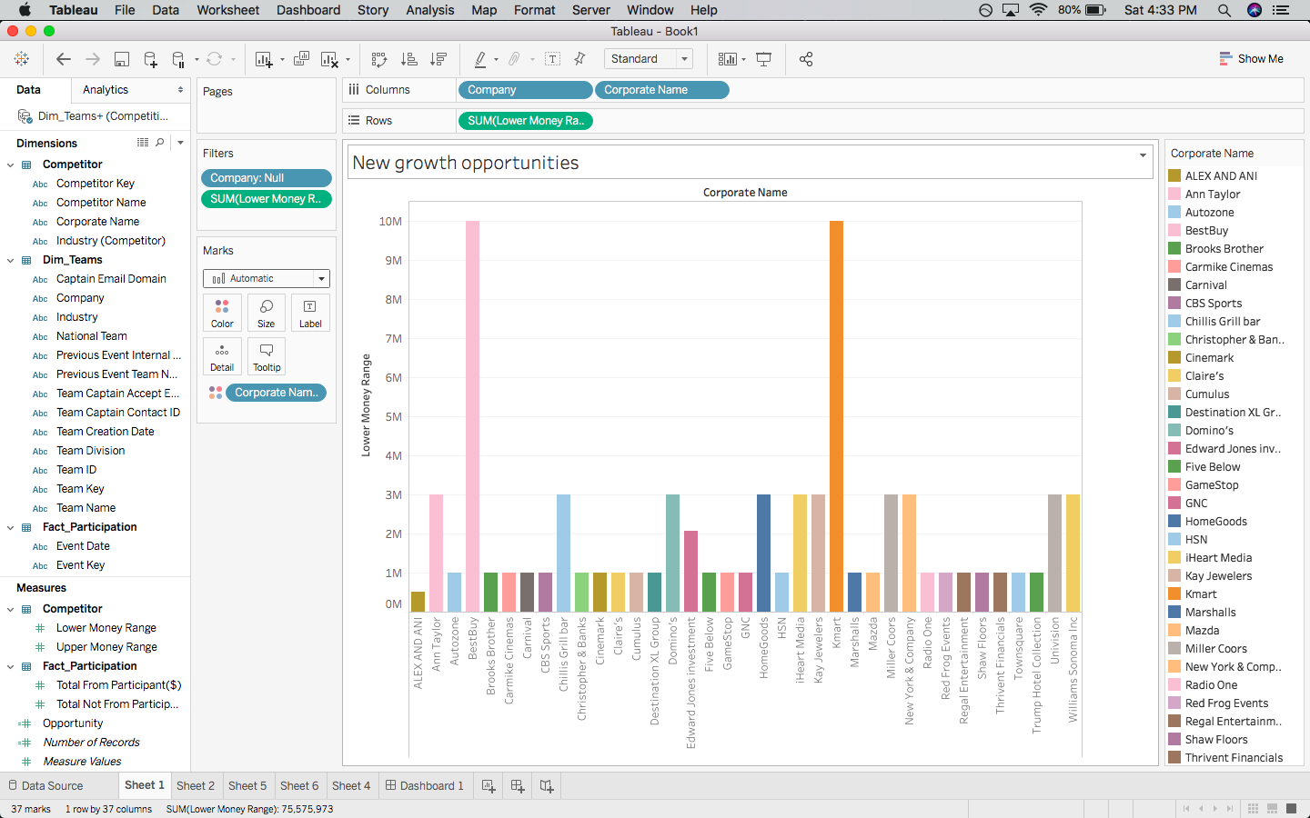

**7.1.2 Can these opportunities be applied to specific rides/markets, especially the biggest events?**

This report shows the biggest events in terms of opportunity which is a function of event goal and revenue earned. The opportunities identified in the previous section could be applied to these events to meet the event goals.

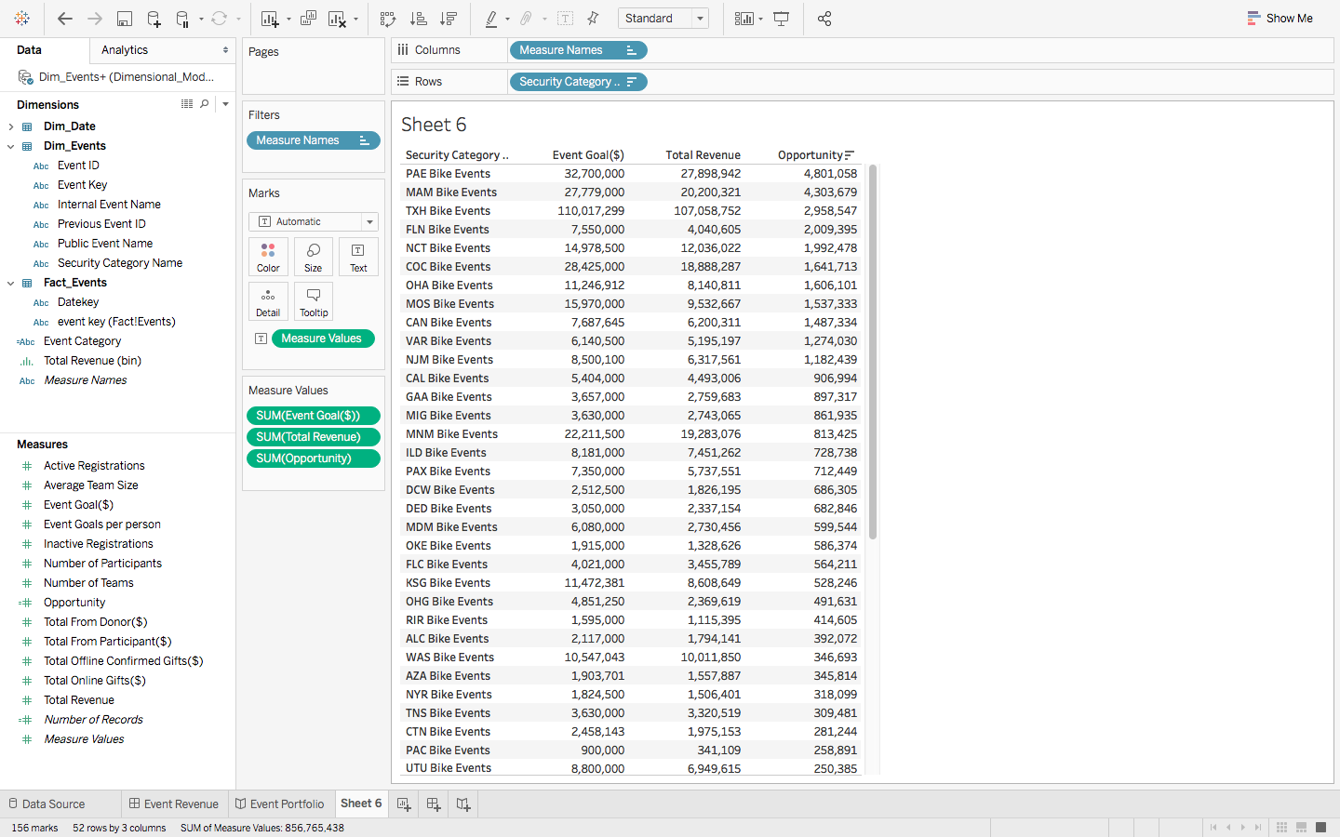

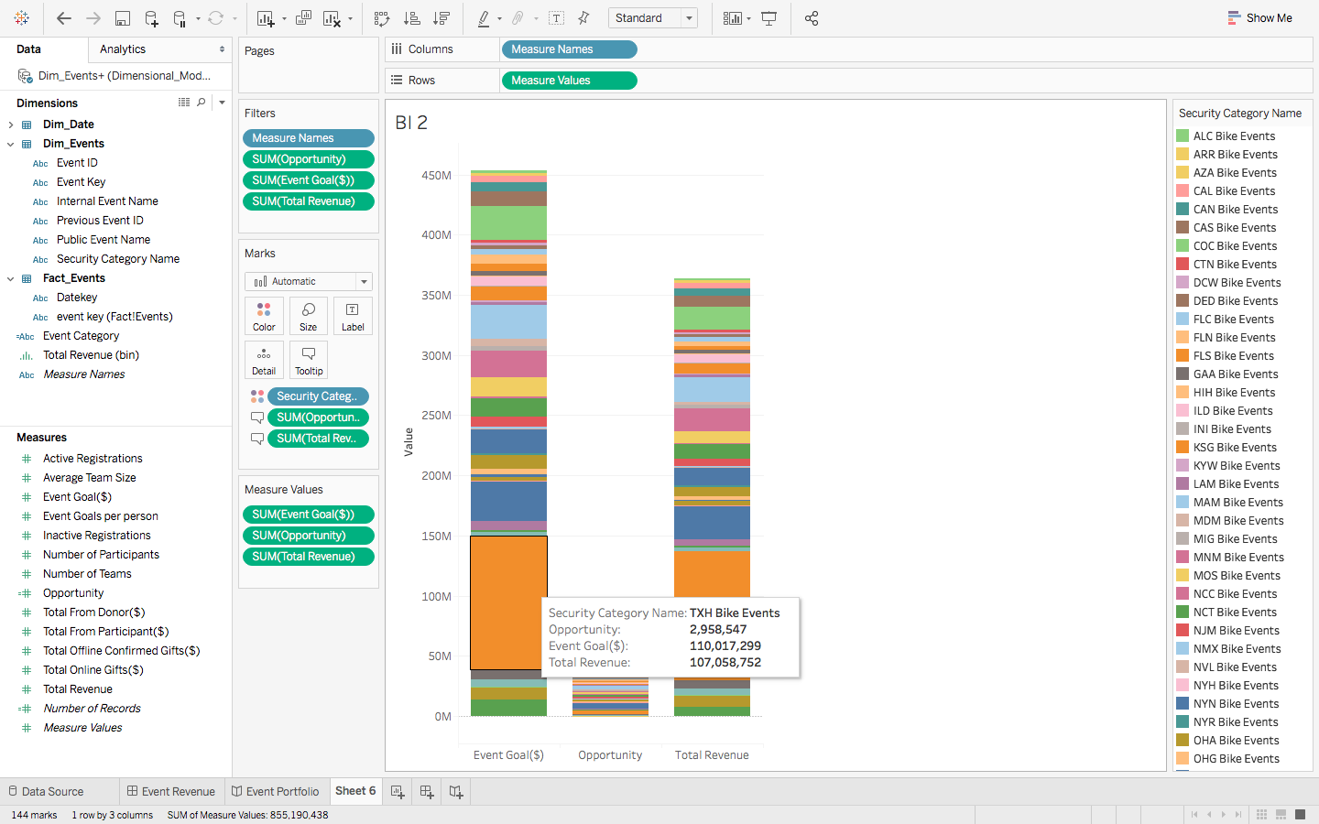

**7.1.3. What industries have had the strongest involvement in Bike MS in the last five years?**

This report shows the industries having the strongest involvement in Bike MS in the last five years.

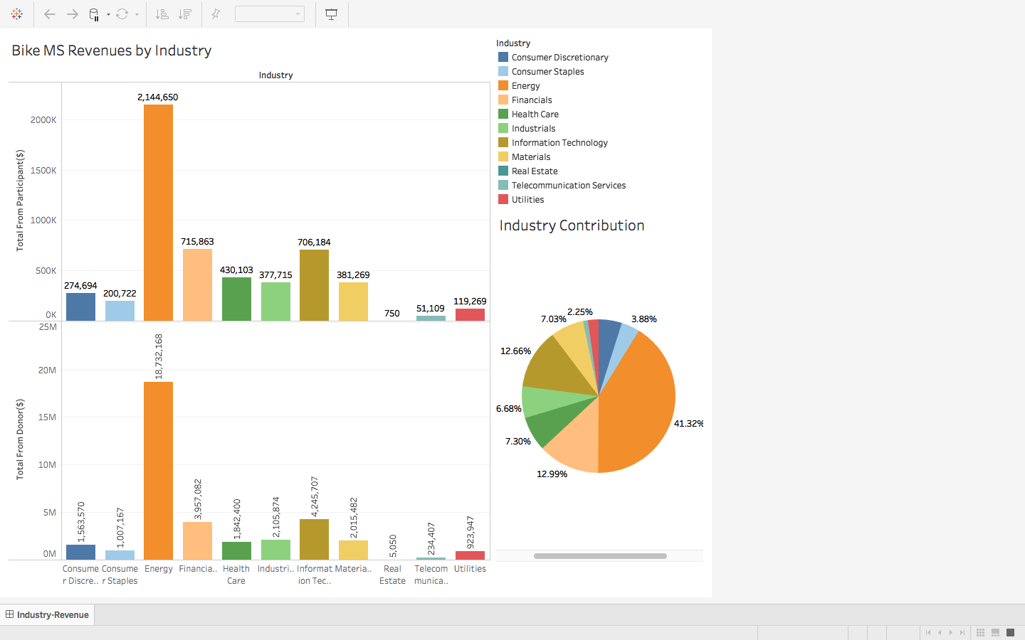

**7.1.4. What occupations were responsible for most of our fundraising?**

This report shows the occupations of the participants that were responsible for most of the fundraising.

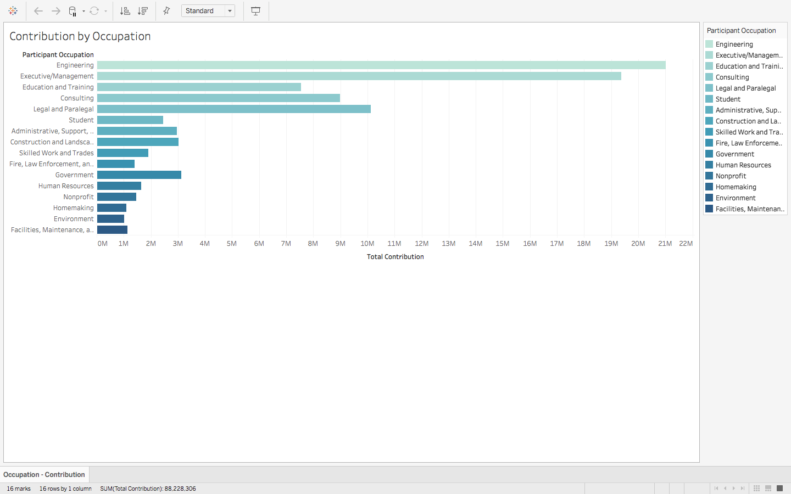

**7.1.5. Can we tie together these industries and occupations to identify gaps/opportunities?**

This report shows the number of industries that each occupation targets and vice-versa.

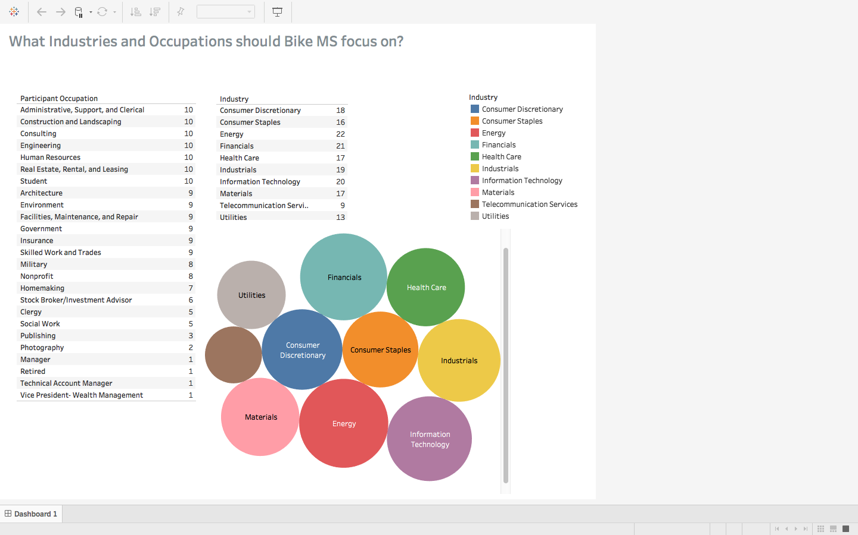

**7.1.6. Common denominator for top performing corporate teams**

This report shows the common denominator for the top performing corporate teams as the connection to MS. Having a connection to MS significantly drives high performing corporate teams.

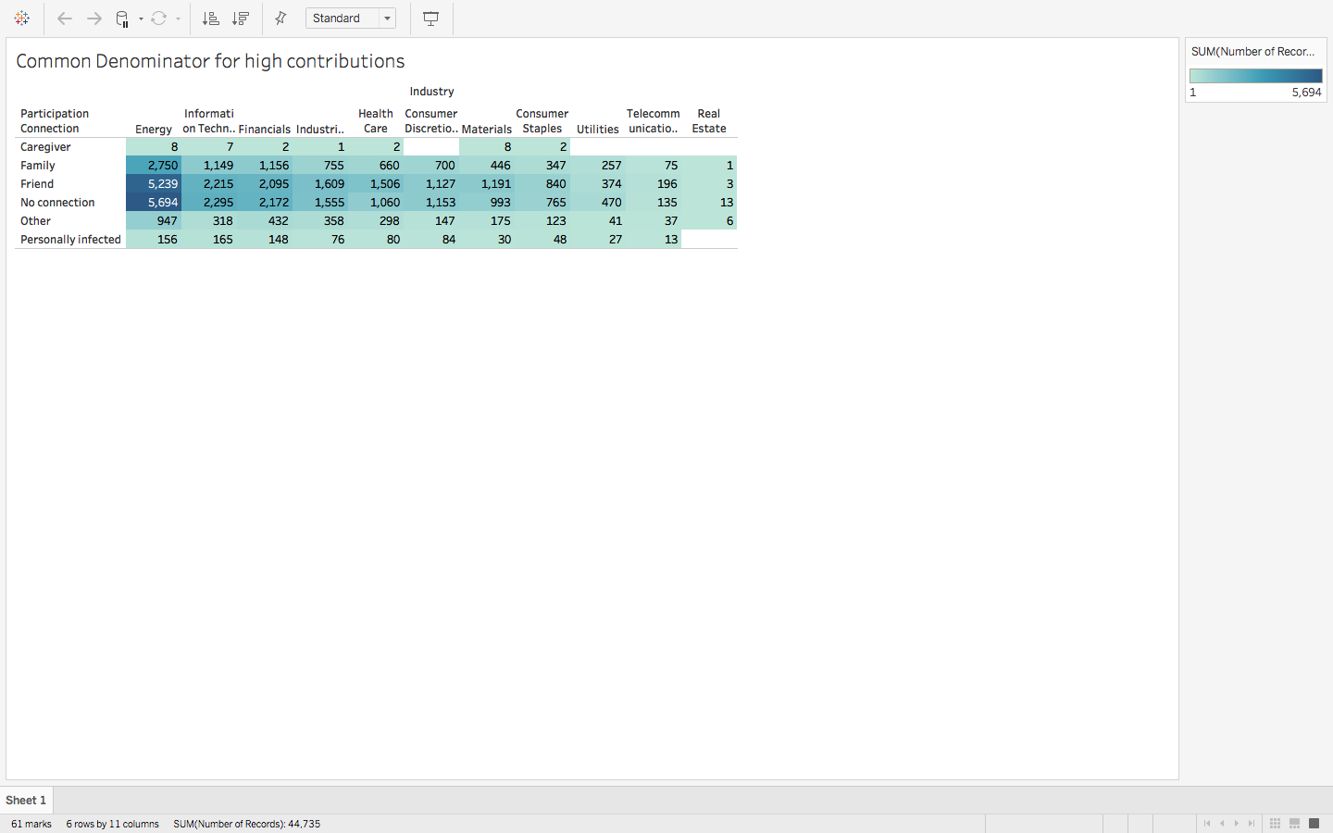



**7.1.7. Can the effect competing events are having in Bike MS’ top markets be quantified?**

The following reports shows the effect of the below competitors that are affecting the top markets of Bike MS:

1. ADA – Tour de Cure
2. Best Buddies
3. JDRF
4. Pedal The Cause
5. St. Jude Children’s Research Hospital

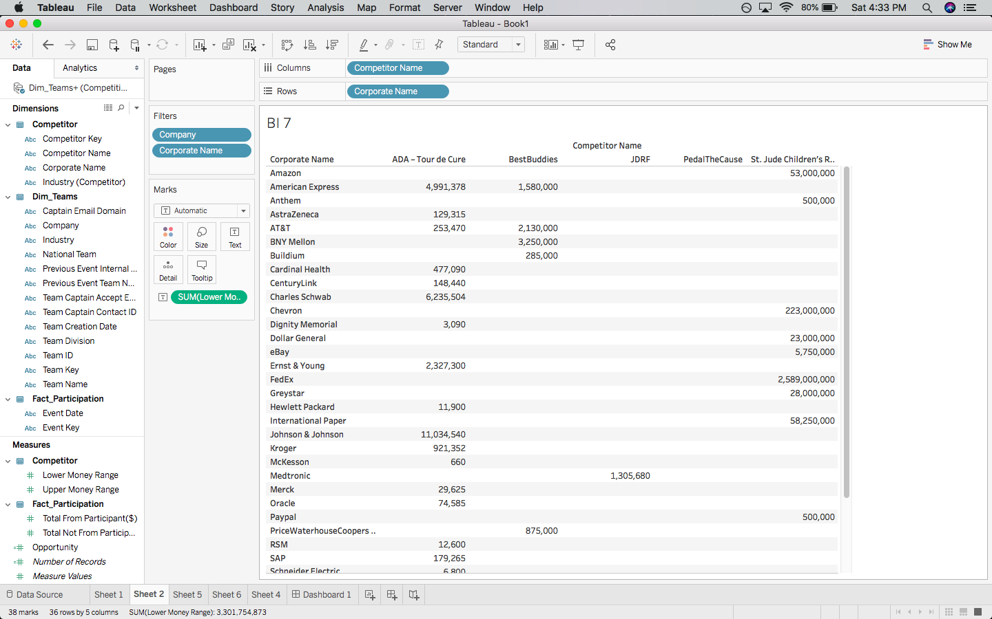

The following two reports shows the potential corporate acquisitions opportunity for Bike MS.

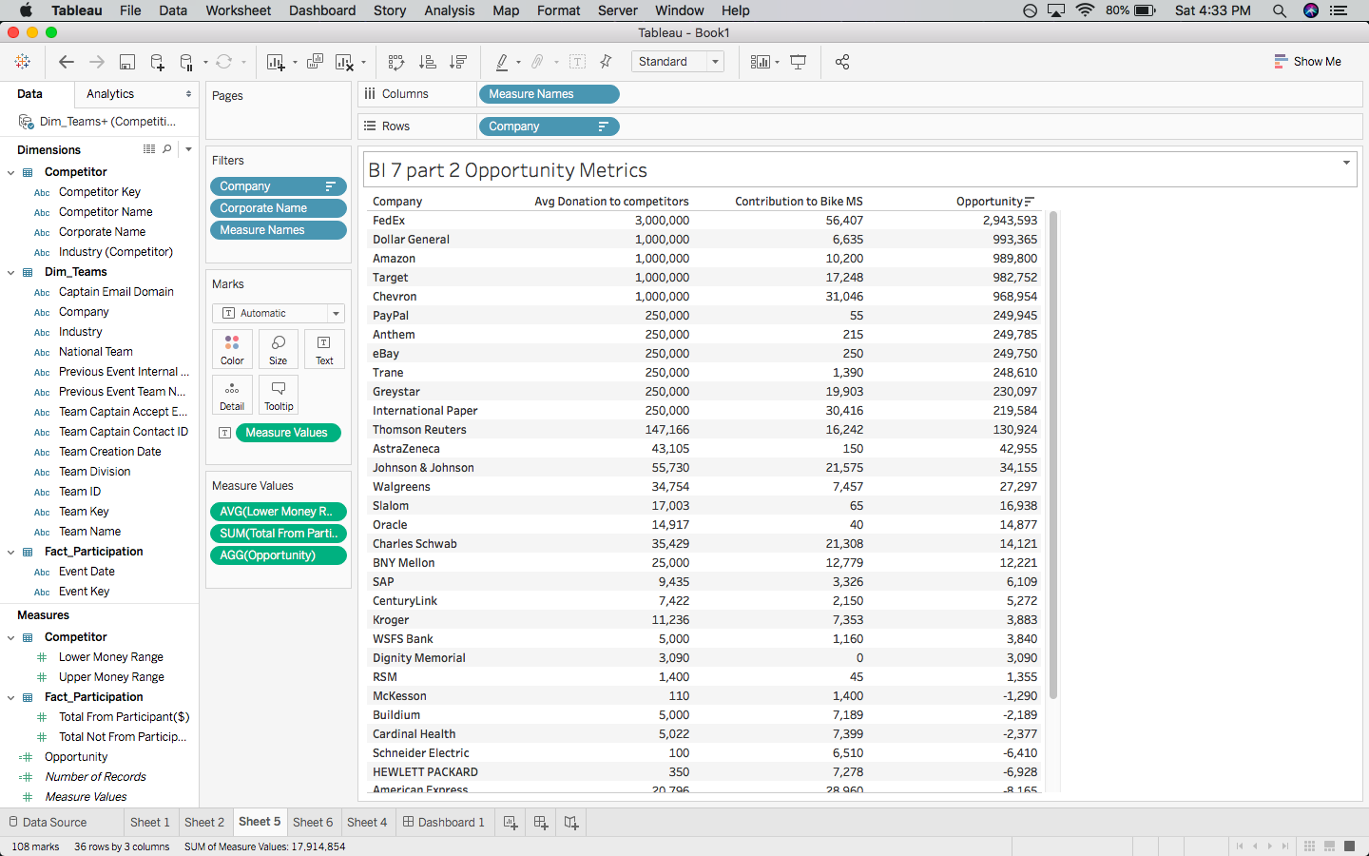

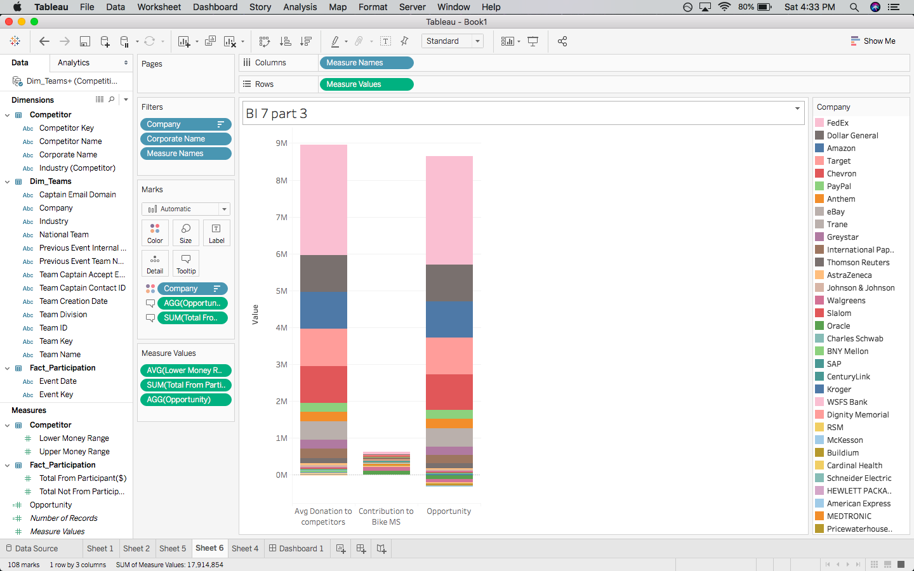

This report shows the donations made by corporate teams to all the competing events as well as Bike MS.

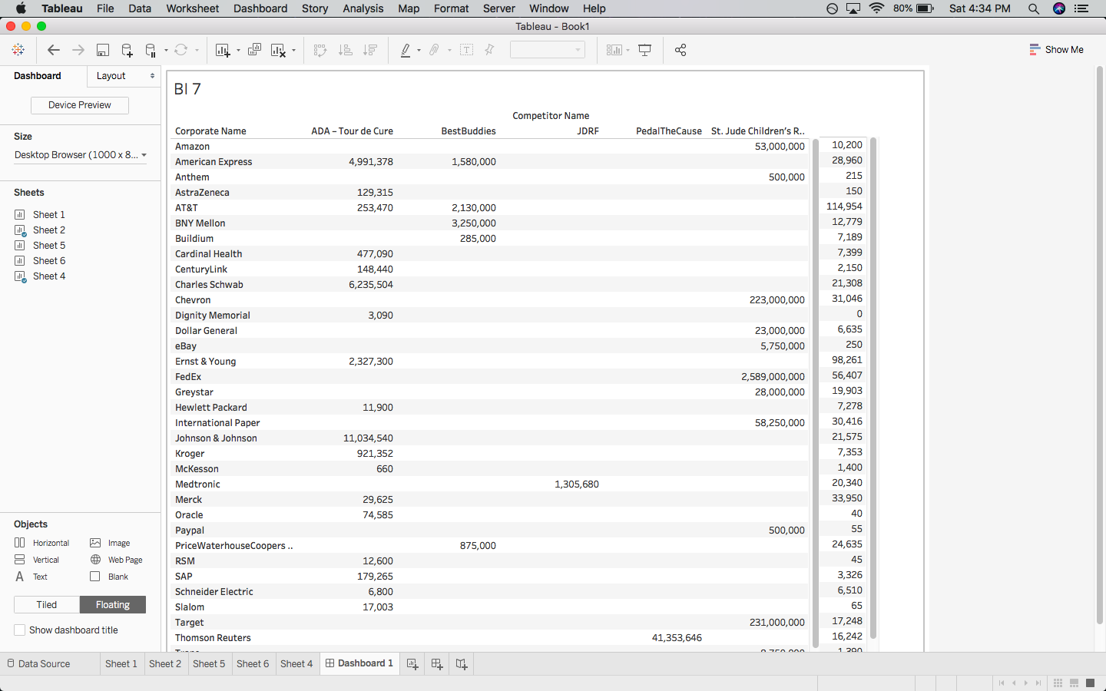

This report shows the rank of each competing event in terms of revenue.

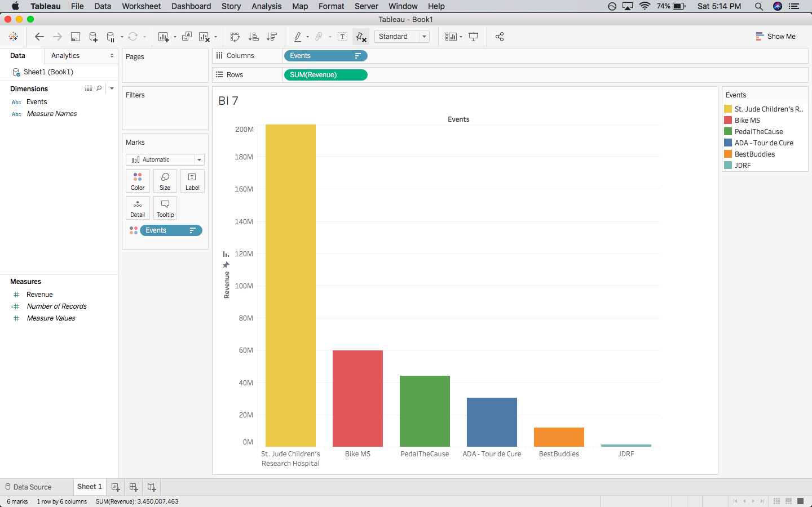

## 7.2 Digital/Social Acquisition Reports

**7.2.1. What are the greatest opportunities for digital marketing investments? Where have we seen the greatest ROI?**

Digital marketing investments are categorized by market as well as by platform.

**7.2.1.1. Digital marketing trends by market**

The following three reports shows the digital marketing trends by market. The market with the lowest cost per action (CPA) are the top performing markets with higher conversion rates and greatest return on investments and therefore, are potential opportunities for more investment.

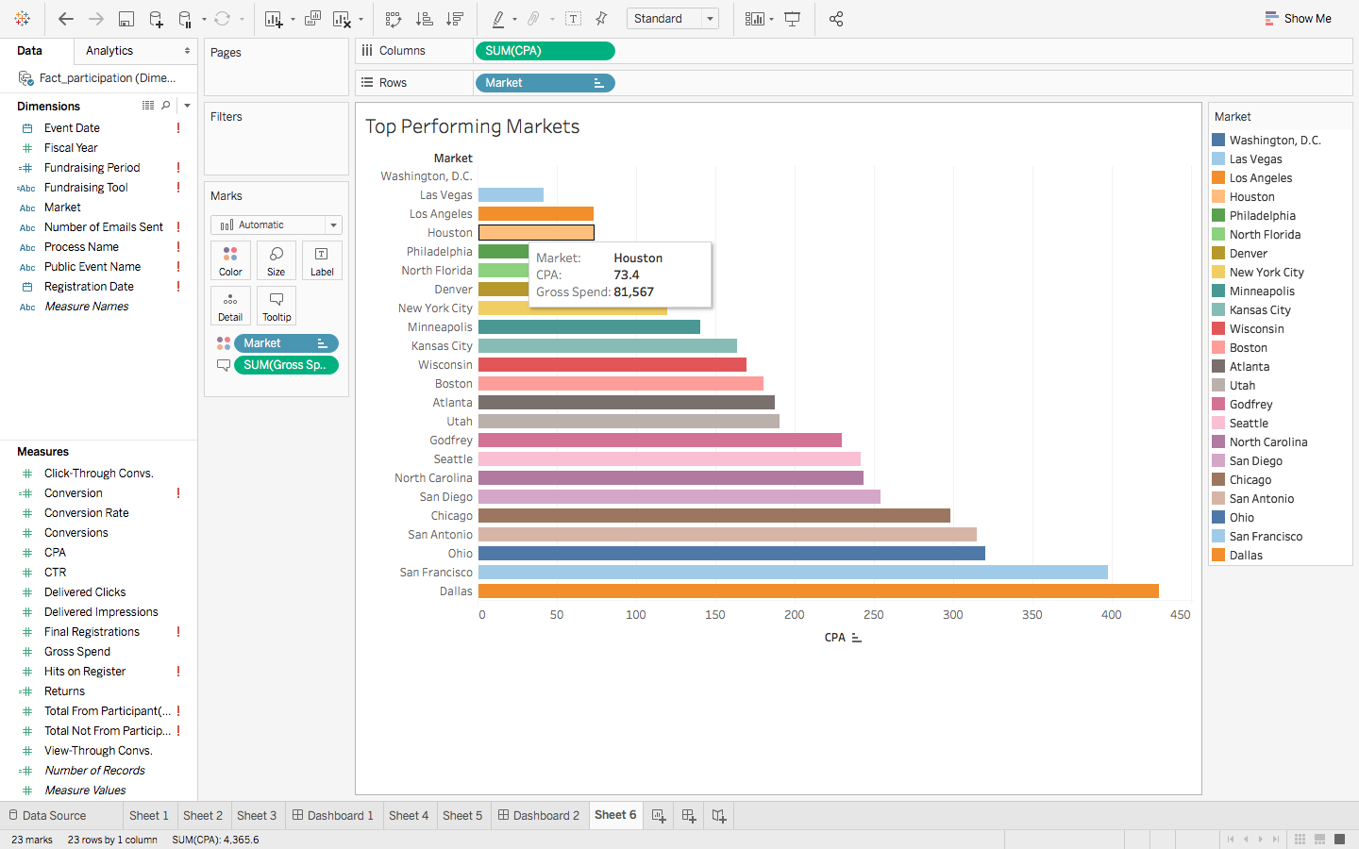

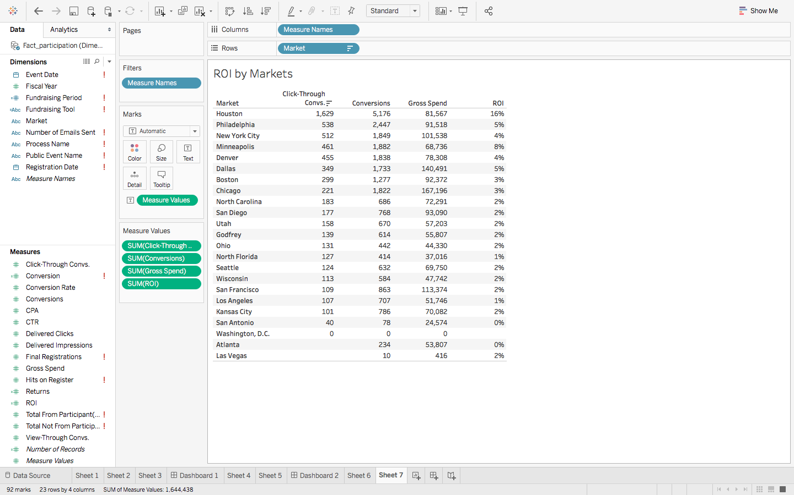

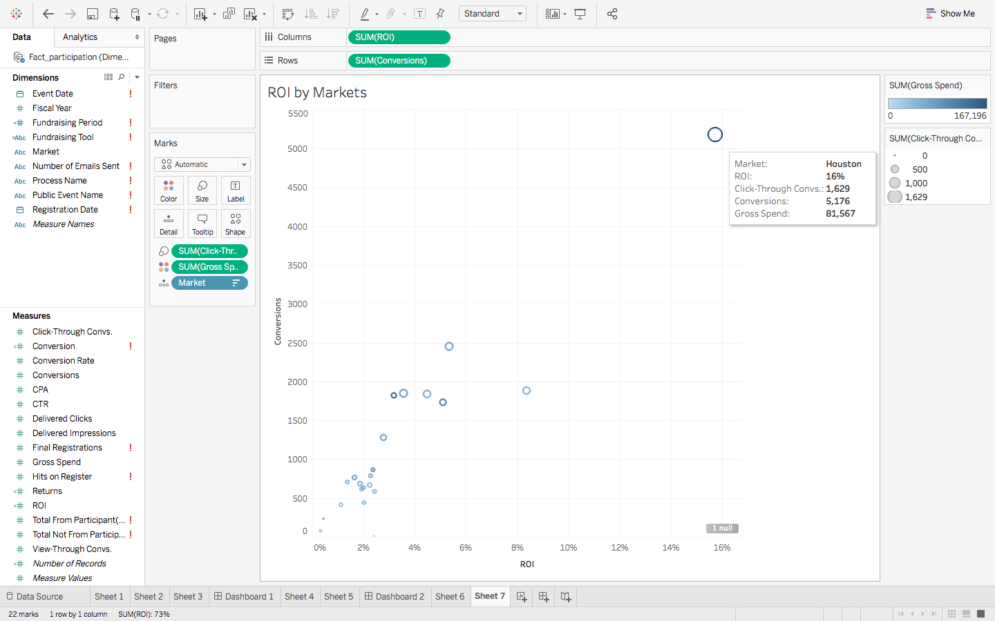

**7.2.1.2. Digital marketing trends by platform**

The following reports shows the digital marketing trends by platform and platform type over the years. The platforms with the lowest cost per action (CPA) are the top performing platforms with higher conversion rates and greatest return on investments and therefore, are potential opportunities for more investment.

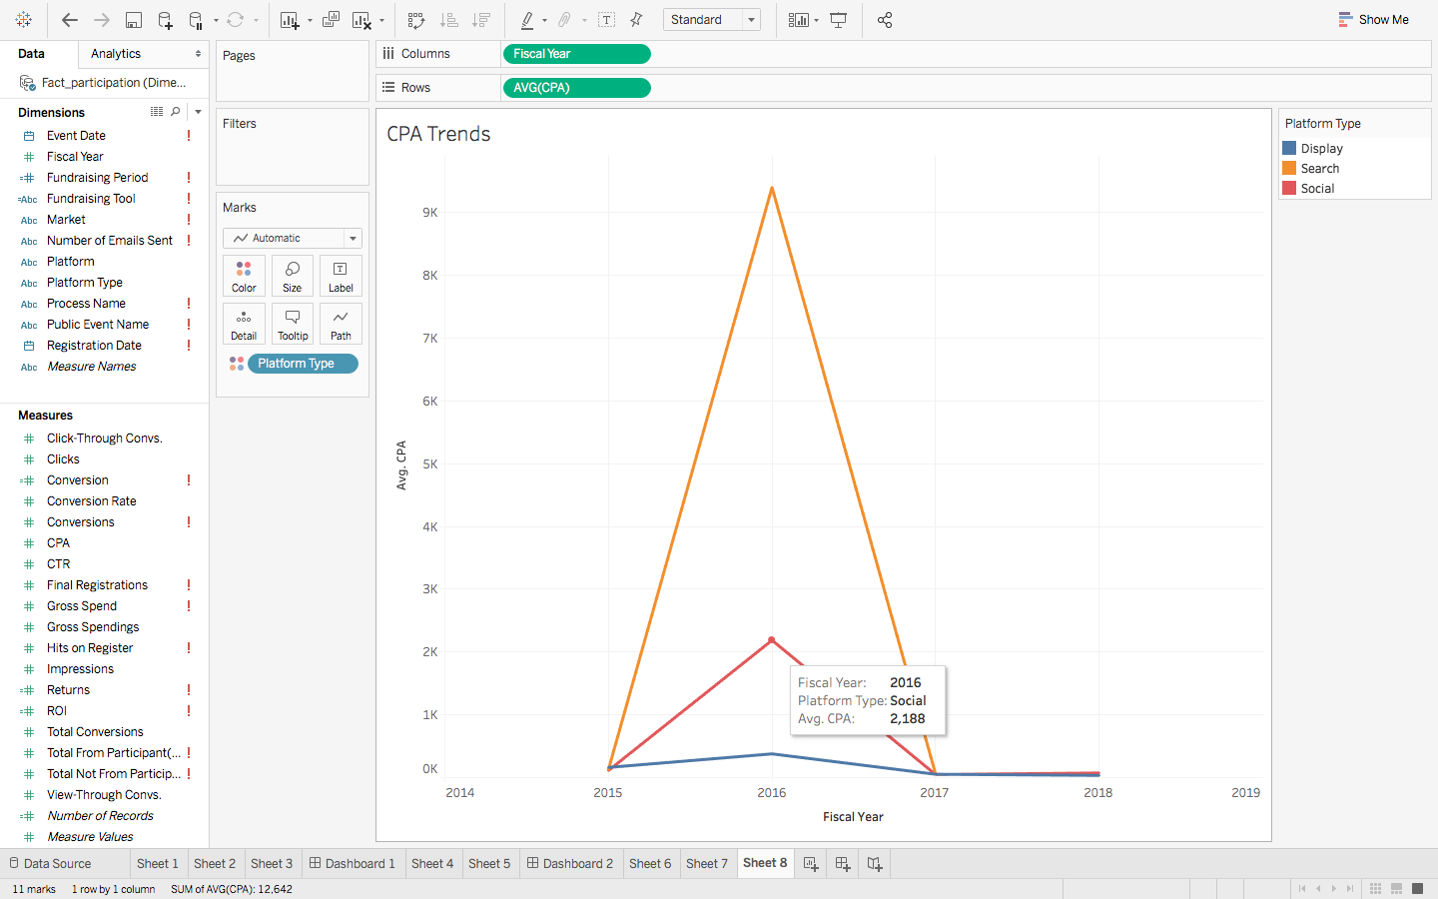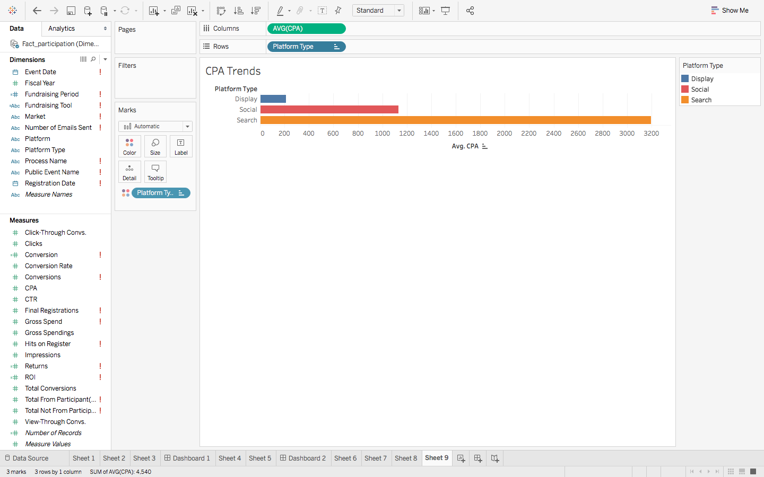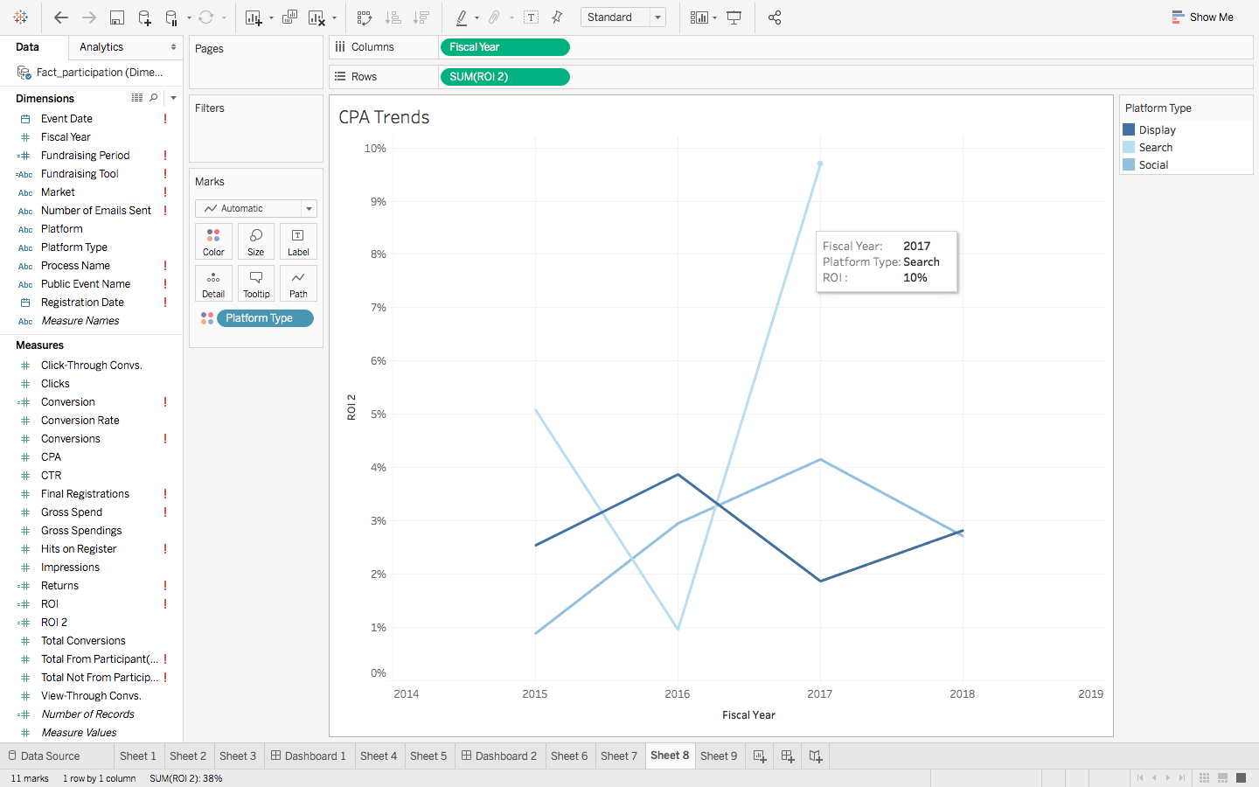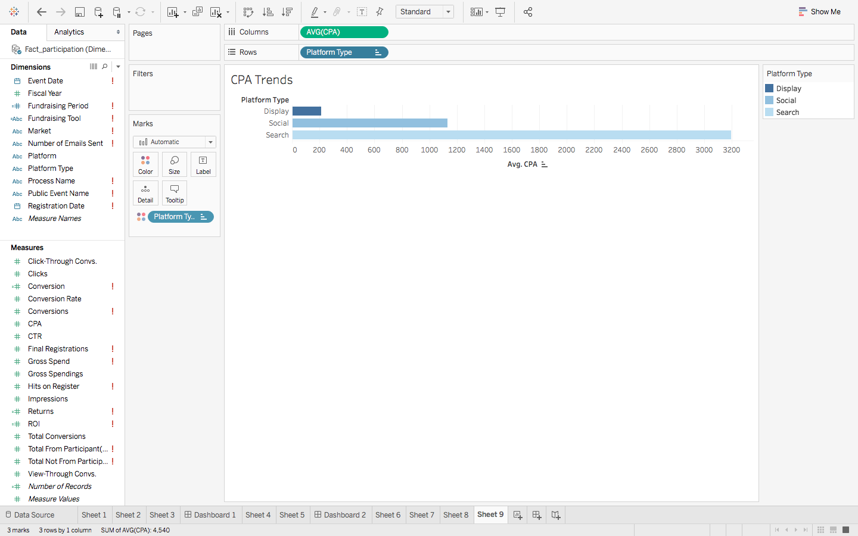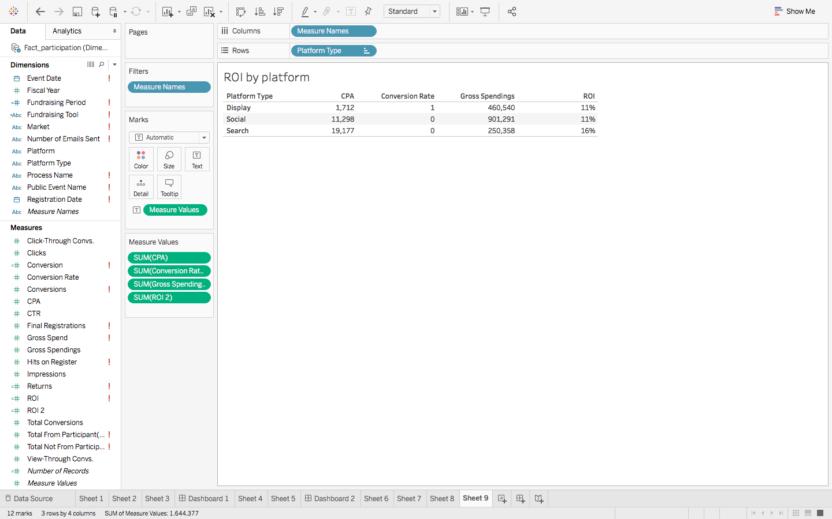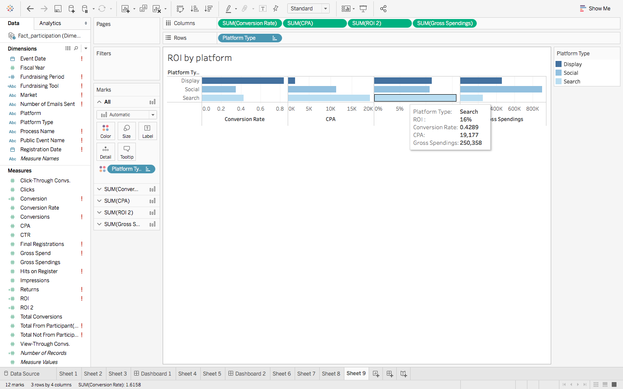

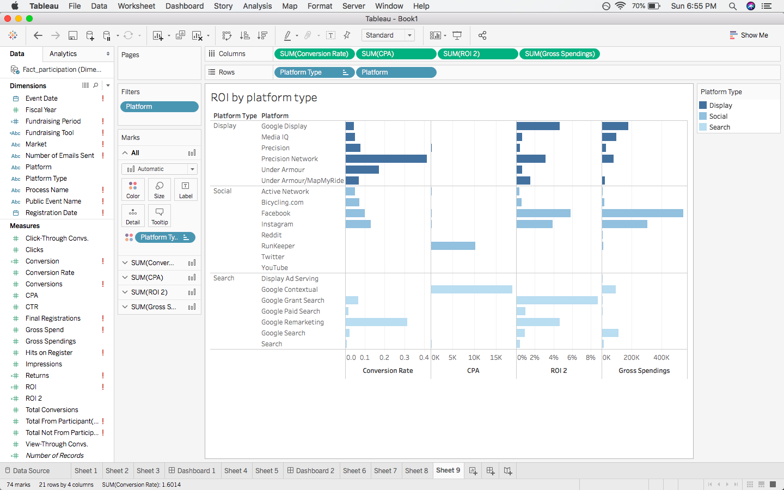

**7.2.2. Once someone is registered, what tactics and behaviors drive fundraising, and at what times leading up to the event?**

The following two reports shows the fundraising behavior- the donations raised by the participant or a team between the registration date and the event date.

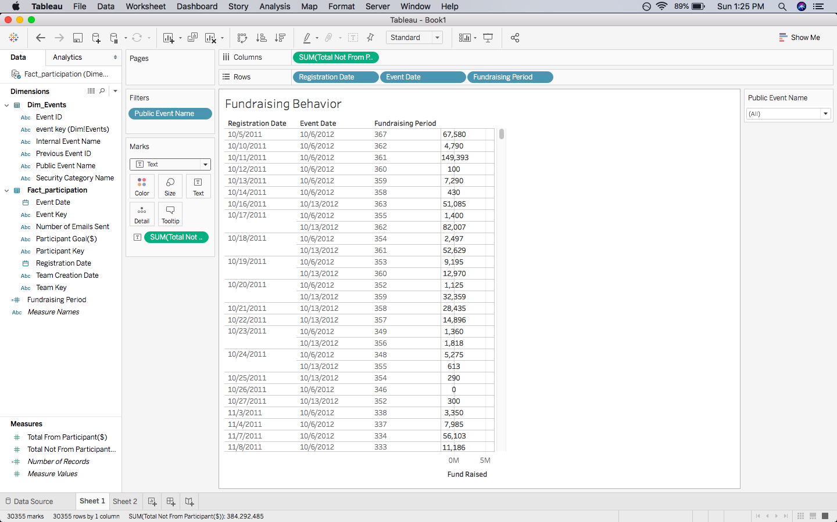

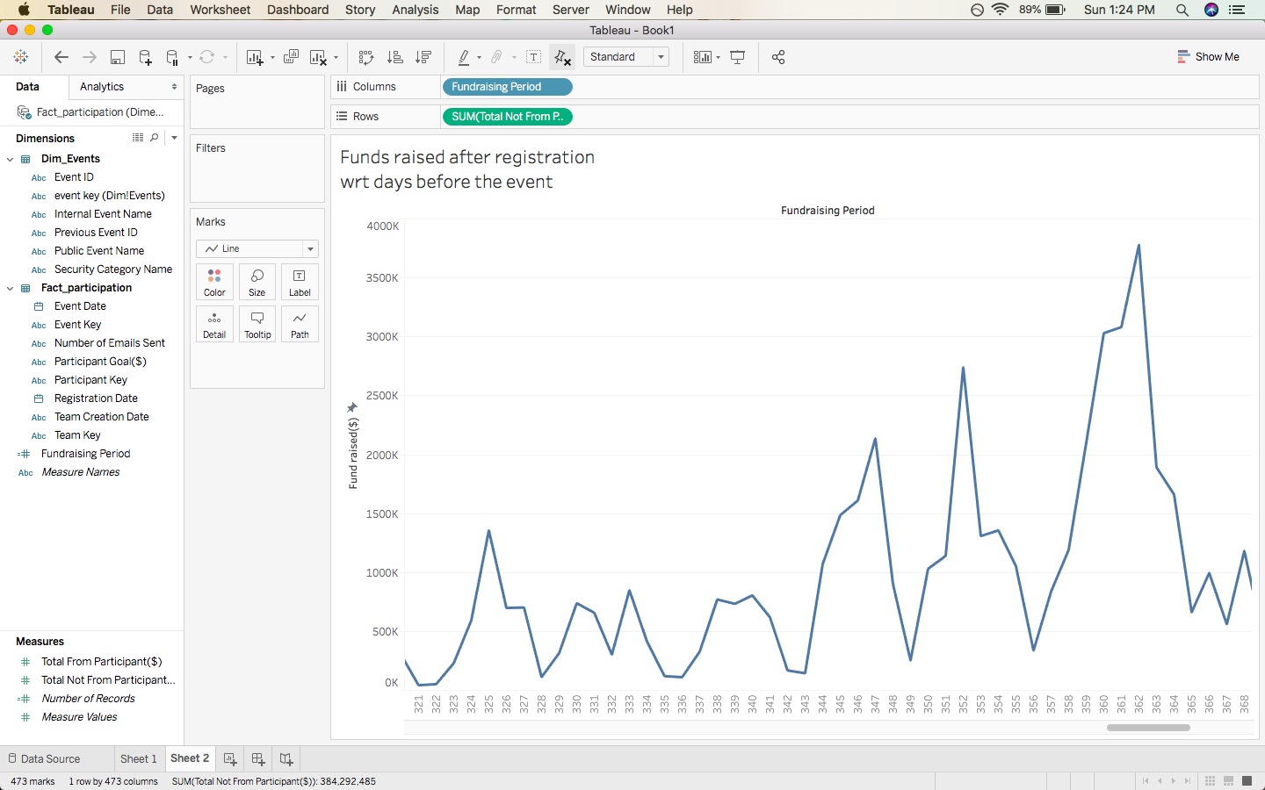

**7.2.3. What behavioral data do you see about usage of our fundraising tools and how it may or may not relate to performance of top fundraisers?**

This report shows the usage of Bike MS’ fundraising tools to raise the donations.

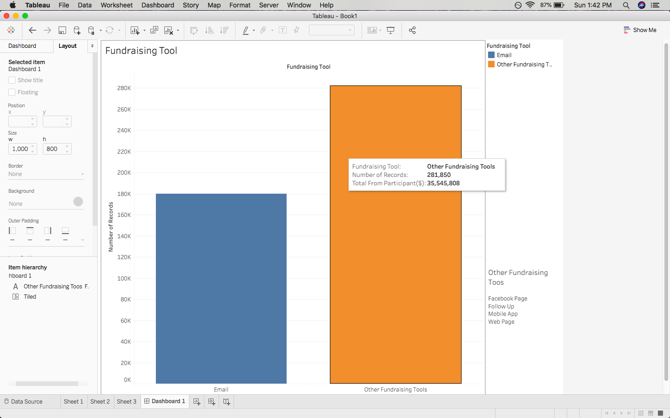

**7.2.4. Despite increasing digital advertising spend, acquisition continues to trend downward overall. Why? Is it an issue of needing more traffic, better targeting, or a conversion rate issue that needs to be addressed through the registration process? What can we do to reverse the trend?**

This report shows the registration trend: registration hits vs final registration i.e. the conversion rates for three ways in which a participant can register.

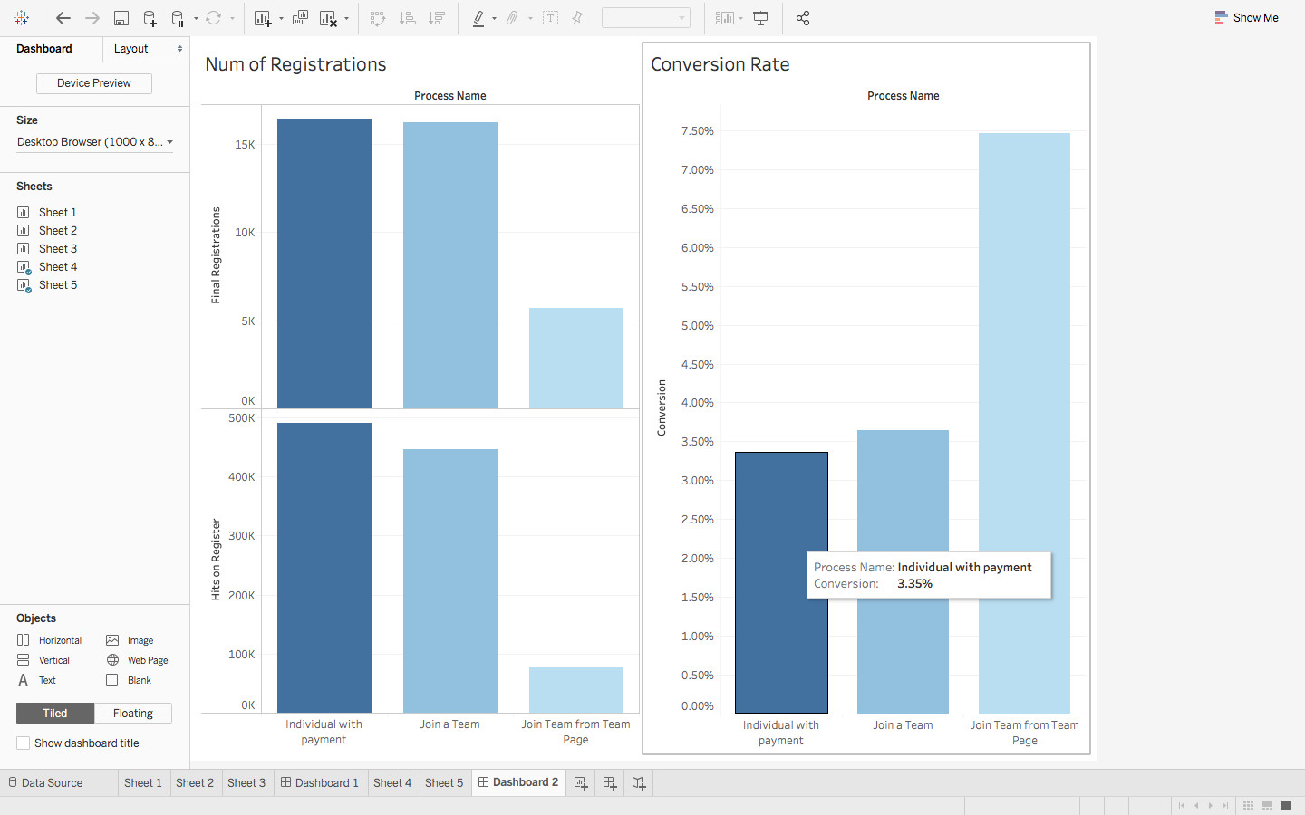

As analyzed in Appendix 1, it’s a **conversion rate issue** that needs to be addressed through the registration process.

**Suggestions to reverse the trends:**

1. Simplify the registration process- single web-page for registration. Also, there are three ways a participant can register for the event- as an individual, as a team, or join an existing team via search. This process can also be simplified and laid out clearly.
2. Show clear results and feedback to the incoming user
3. Make it more user friendly

## 7.3 Other Insights

As we studied this data, following things came up as an insight into the operations that the questions above do not capture.

* + 1. **Events Analysis**

This report shows the revenue raised in each event based on the donations made by the donor and the donations raised by the participants.

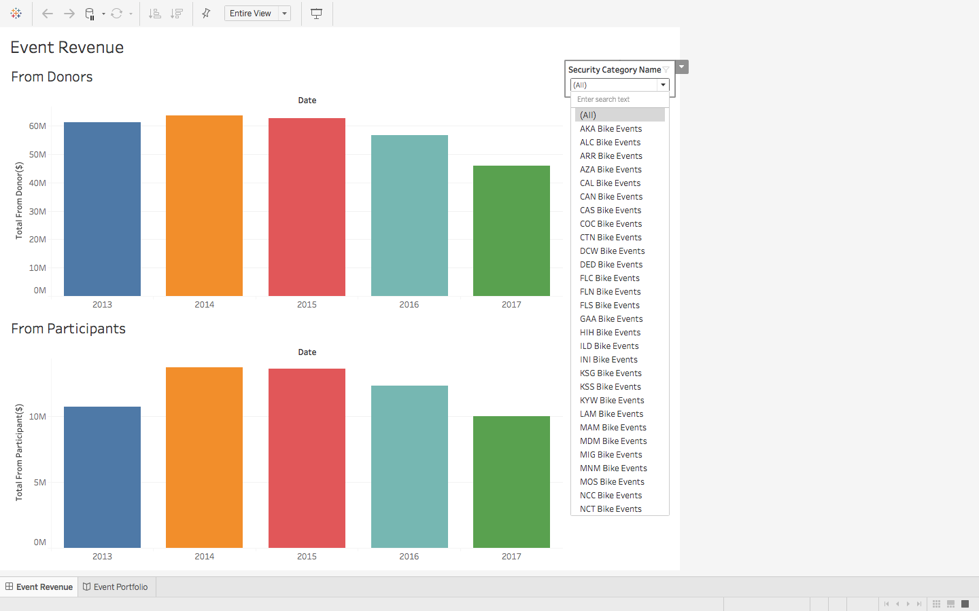

This report shows the distribution of donations by channel type- online vs offline, categorized by events.

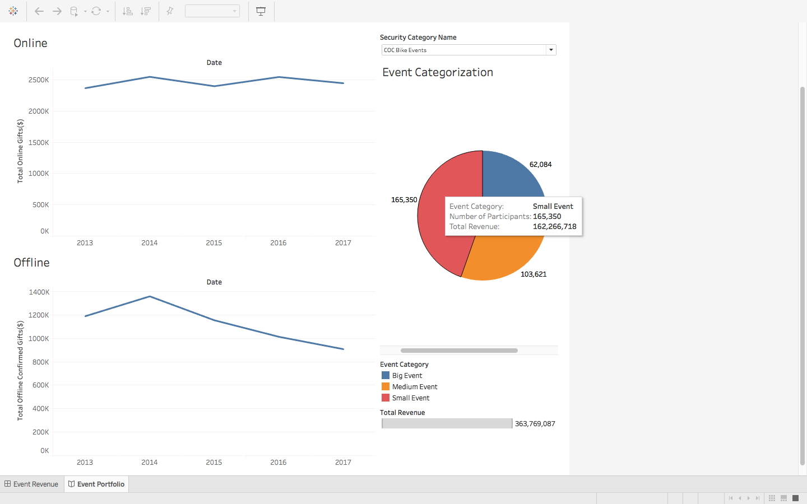

**7.3.2 Donations Analysis**

This report shows the donation made by the donors over the years. As seen, donor connection to MS is not a driving factor for people making donations to the event.

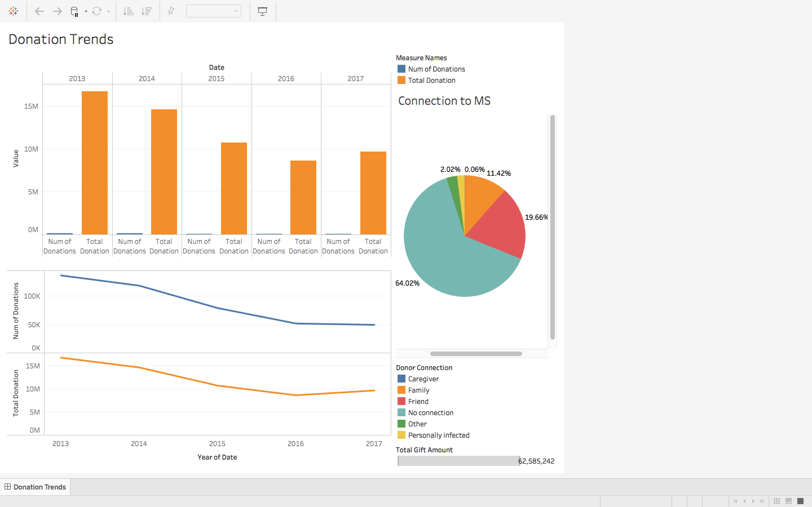

# Metadata Documentation

## 8.1 External data sources metadata

|  |  |
| --- | --- |
| **Metadata** | **Description** |
| Name | Industry |
| Brief Description | The industry each participating corporate teams belongs to. |
| Attributes | * Company (PK) * Industry |
| Load Frequency | Yearly |

*Source: Forbes[8], S&P[9]*

|  |  |
| --- | --- |
| **Metadata** | **Description** |
| Name | Competitors |
| Brief Description | The information about the competing events for Bike MS. |
| Attributes | * Competitor_Key (PK) * Competitor_Name * UpperMoneyRange * LowerMoneyRange * CorporateName * Industry |
| Load Frequency | Yearly |

*Source: ADA – Tour de Cure[10]; Best Buddies[11]; JDRF[12]; PedalTheCause[13]; St. Jude Children’s Research Hospital[14]*

## 8.2 Dimensions metadata

|  |  |
| --- | --- |
| **Dimension Metadata** | **Description** |
| Name | Dim_Team |
| Brief Description | The bike team that participates in the Bike MS events to raise fundings. |
| Conformed Dimension | Yes |
| Hierarchy | None |
| Change Rules | * Team_Key: SCD Type-1 * TeamName: SCD Type-1 * TeamCreationDate: SCD Type-1 * TeamCaptainContactID: SCD Type-1 * TeamDivision: SCD Type-1 * NationalTeam: SCD Type-1 * Company: SCD Type-1 * Industry: SCD Type-1 * isCompetitor: SCD Type-1 |
| Load Frequency | Daily |

|  |  |
| --- | --- |
| **Dimension Metadata** | **Description** |
| Name | Dim_Events |
| Brief Description | The fundraising event that the bike teams join. |
| Conformed Dimension | Yes |
| Hierarchy | None |
| Change Rules | * Event_Key: SCD Type-1 * PublicEventName: SCD Type-1 * InternalEventName: SCD Type-1 * SecurityCategoryName: SCD Type-1 |
| Load Frequency | Daily |

|  |  |
| --- | --- |
| **Dimension Metadata** | **Description** |
| Name | Dim_Participants |
| Brief Description | The team members of the bike team. |
| Conformed Dimension | Yes |
| Hierarchy | None |
| Change Rules | * Participant_Key: SCD Type-1 * ParticipantGender: SCD Type-1 * Participant_Connection_to_MS: SCD Type-1 * Participant_Registration_Type: SCD Type-2 * RegistrationActiveStatus: SCD Type-1 * IsTeamCaptain: SCD Type-1 * ParticipantEmployer: SCD Type-1 * ParticipantOccupation: SCD Type-1 * ParticipantContactID: SCD Type-1 * Effective_Date: SCD Type-1 * Current_Flag: SCD Type-1 * ParticipantType: SCD Type-2 |
| Load Frequency | Daily |

|  |  |
| --- | --- |
| **Dimension Metadata** | **Description** |
| Name | Dim_Donors |
| Brief Description | The people that donate money or gift items to the fundraising event. |
| Conformed Dimension | Yes |
| Hierarchy | None |
| Change Rules | * Donor_Key: SCD Type-1 * DonorMemberID: SCD Type-1 * DonorGender: SCD Type-1 * DonorOptoutDate: SCD Type-1 * DonorOptoutMethod: SCD Type-1 * DonorConnectionToMS: SCD Type-1 * DonorEmpolyer: SCD Type-1 * DonorConsID: SCD Type-1 * DonorEmailStatus: SCD Type-1 * DonorAcceptEmail: SCD Type-1 |
| Load Frequency | Daily |

|  |  |
| --- | --- |
| **Dimension Metadata** | **Description** |
| Name | Dim_MarketAdvertisements |
| Brief Description | The advertisements that NMSS put for the events in the market. |
| Conformed Dimension | Yes |
| Hierarchy | None |
| Change Rules | * Market_Key: SCD Type-1 * MarketName: SCD Type-1 |
| Load Frequency | Daily |

|  |  |
| --- | --- |
| **Dimension Metadata** | **Description** |
| Name | Dim_PlatformAdvertisements |
| Brief Description | The advertisements that NMSS put for the events on the platform. |
| Conformed Dimension | Yes |
| Hierarchy | None |
| Change Rules | * Platform_Key: SCD Type-1 * PlatformName: SCD Type-1 * PlatformType: SCD Type-1 |
| Load Frequency | Daily |

|  |  |
| --- | --- |
| **Dimension Metadata** | **Description** |
| Name | Dim_Affiliates |
| Brief Description | Original 3-byte chapter code. |
| Conformed Dimension | Yes |
| Hierarchy | None |
| Change Rules | * Affiliate_Key: SCD Type-1 * Chapter_Name: SCD Type-1 * Affiliate_Code_mrg: SCD Type-1 * Affiliate_Code |
| Load Frequency | Daily |

|  |  |
| --- | --- |
| **Dimension Metadata** | **Description** |
| Name | Dim_GoogleAnalytics |
| Brief Description | The process of Google Analytics |
| Conformed Dimension | Yes |
| Hierarchy | None |
| Change Rules | * Process_Key: SCD Type-1 * Process_Name: SCD Type-1 |
| Load Frequency | Daily |

|  |  |
| --- | --- |
| **Dimension Metadata** | **Description** |
| Name | Dim_Date |
| Brief Description | The calendar date. |
| Conformed Dimension | Yes |
| Hierarchy | Day < Week < Month < Season < Year |
| Change Rules | * Date_Key: SCD Type-1 * Date: SCD Type-1 * Month: SCD Type-1 * Year: SCD Type-1 * Day: SCD Type-1 * WeekNo: SCD Type-1 * MonthName: SCD Type-1 * Season: SCD Type-1 * IsWeekend: SCD Type-1 |
| Load Frequency | Daily |

## 8.3 Facts metadata

|  |  |
| --- | --- |
| **Fact Table Metadata** | **Description** |
| Name | Fact_Participation |
| Type | Accumulating Periodic Snapshot Fact Table |
| Relevant Dimensions | * Events * Team * Participants * Date |
| Degenerate Dimension | None |
| Measures/Facts Description | * NumberofEmailsSent: sum of the emails sent. * TotalFromParticipants: sum of donations raised from the participant. * ParticipantGoal: fundraising goal of the participant. |
| Measures/Facts Type | * NumberofEmailsSent: additive * TotalFromParticipants: additive * ParticipantGoal: additive |
| Format of the Measures/Facts | * NumberofEmailsSent: INT[10] * TotalFromParticipants: INT[10] * ParticipantGoal: INT[10] |
| Load Frequency | Daily |

|  |  |
| --- | --- |
| **Fact Table Metadata** | **Description** |
| Name | Fact_Donations |
| Type | Transaction Fact Table |
| Relevant Dimensions | * Donor * Affiliate * Events * Date |
| Degenerate Dimension | None |
| Measures/Facts Description | * TotalGiftAmount: sum of donations from the donor. |
| Measures/Facts Type | * TotalGiftAmount: additive |
| Format of the Measures/Facts | * TotalGiftAmount: INT[10] |
| Load Frequency | Daily |

|  |  |
| --- | --- |
| **Fact Table Metadata** | **Description** |
| Name | Fact_Events |
| Type | Transaction Fact Table |
| Relevant Dimensions | * Events * Date |
| Degenerate Dimension | None |
| Measures/Facts Description | * Event_Goal: the fundraising goal of the event. * AverageTeamSize: the average size of the teams in an event. * NumberOfTeams: the total amount of the teams that participate in the event. * NumberOfParticipants: the total amount of the participants that participate in the event. * EventsGoalsPerPerson: the average number of the fundraising goal of each person. * ActiveRegistration: the total amount of the participants that register actively. * InactiveRegistration: the total amount of the participants that register inactively. * TotalOffineGifts: the total amount of the offline gifts. * TotalOnlineGifts: the total amount of the online gifts. * TotalRevenue: the total amount of the revenue of the event. * TotalFromParticipants: the total amount of funds raised from the participants. * TotalFromDonors: the total amount of funds raised from the donors. |
| Measures/Facts Type | * Event_Goal: additive * AverageTeamSize: non-additive * NumberOfTeams: additive * NumberOfParticipants: additive * EventsGoalsPerPerson: non-additive * ActiveRegistration: additive * InactiveRegistration: additive * TotalOffineGifts: additive * TotalOnlineGifts: additive * TotalRevenue: additive * TotalFromParticipants:additive * TotalFromDonors: additive |
| Format of the Measures/Facts | * Event_Goal: INT[10] * AverageTeamSize: INT[3] * NumberOfTeams: INT[5] * NumberOfParticipants: INT[6] * EventsGoalsPerPerson: INT[7] * ActiveRegistration: INT[5] * InactiveRegistration: INT[5] * TotalOffineGifts: INT[10] * TotalOnlineGifts: INT[10] * TotalRevenue: INT[10] * TotalFromParticipants: INT[10] * TotalFromDonors: INT[10] |
| Load Frequency | Daily |

|  |  |
| --- | --- |
| **Fact Table Metadata** | **Description** |
| Name | Fact_MarketAdvertisement_Analysis |
| Type | Transaction Fact Table |
| Relevant Dimensions | * MarketAdvertisements * Date |
| Degenerate Dimension | None |
| Measures/Facts Description | * DeliveredImpressions: the total number of the delivered impressions of the advertisement. * DeliveredClicks: the total number of the delivered clicks of the advertisement. * CTR: the ratio of users who click on a specific link to the number of total users who view the advertisement. * Click-ThroughConversions: the total number of the clicks through conversions. * View-ThroughConversions: the total number of the views through conversions. * TotalConversions: click-through conversions plus view through conversions. * ConversionRate: the percentage of visitors to the advertisement that complete a desired goal (a conversion) out of the total number of visitors. * GrossSpend: the gross spend on putting the advertisement. * CPA: (cost per acquisition) How much the business pays in order to attain a conversion. |
| Measures/Facts Type | * DeliveredImpressions: additive * DeliveredClicks: additive * CTR: additive * Click-ThroughConversions: additive * View-ThroughConversions: additive * TotalConversions: additive * ConversionRate: non-additive * GrossSpend: additive * CPA: non-additive |
| Format of the Measures/Facts | * DeliveredImpressions: INT[7] * DeliveredClicks: INT[7] * CTR: INT[10] * Click-ThroughConversions: INT[7] * View-ThroughConversions: INT[7] * TotalConversions: INT[10] * ConversionRate: FLOAT * GrossSpend: INT[7] * CPA: FLOAT |
| Load Frequency | Daily |

|  |  |
| --- | --- |
| **Fact Table Metadata** | **Description** |
| Name | Fact_PlatformAdvertisement_Analysis |
| Type | Transaction Fact Table |
| Relevant Dimensions | * PlatformAdvertisements * Date |
| Degenerate Dimension | None |
| Measures/Facts Description | * DeliveredImpressions: the total number of the delivered impressions of the advertisement. * DeliveredClicks: the total number of the delivered clicks of the advertisement. * CTR: the ratio of users who click on a specific link to the number of total users who view the advertisement. * Click-ThroughConversions: the total number of the clicks through conversions. * View-ThroughConversions: the total number of the views through conversions. * TotalConversions: click-through conversions plus view through conversions. * ConversionRate: the percentage of visitors to the advertisement that complete a desired goal (a conversion) out of the total number of visitors. * GrossSpend: the gross spend on putting the advertisement. * CPA: (cost per acquisition) How much the business pays in order to attain a conversion. |
| Measures/Facts Type | * DeliveredImpressions: additive * DeliveredClicks: additive * CTR: additive * Click-ThroughConversions: additive * View-ThroughConversions: additive * TotalConversions: additive * ConversionRate: non-additive * GrossSpend: additive * CPA: non-additive |
| Format of the Measures/Facts | * DeliveredImpressions: INT[7] * DeliveredClicks: INT[7] * CTR: INT[10] * Click-ThroughConversions: INT[7] * View-ThroughConversions: INT[7] * TotalConversions: INT[10] * ConversionRate: FLOAT * GrossSpend: INT[7] * CPA: FLOAT |
| Load Frequency | Daily |

|  |  |
| --- | --- |
| **Fact Table Metadata** | **Description** |
| Name | Fact_GoogleAnalytics |
| Type | Transaction Fact Table |
| Relevant Dimensions | * GoogleAnalytics * Date |
| Degenerate Dimension | None |
| Measures/Facts Description | * HitsOnTeamPage: the total number of the hits on team page. * HitsOnRegister: the total number of the hits on registration page. * HitsonSearchForTeam: the total number of the hits on searching for team page. * HitsOnSearchResults: the total number of the hits on searching results page. * HitsOnSelectOptions: the total number of the hits on selecting options page. * HitsOnProvideDetails: the total number of the hits on providing details page. * HitsOnAgreeToTerms: the total number of the hits on “agree to terms” page. * HitsOnReview: the total number of the hits on review page. * HitsOnPayment: the total number of the hits on payment page. * FinalRegistrations the total number of the hits on final registration page. |
| Measures/Facts Type | * HitsOnTeamPage: additive * HitsOnRegister: additive * HitsonSearchForTeam: additive * HitsOnSearchResults: additive * HitsOnSelectOptions: additive * HitsOnProvideDetails: additive * HitsOnAgreeToTerms: additive * HitsOnReview: additive * HitsOnPayment: additive * FinalRegistrations: additive |
| Format of the Measures/Facts | * HitsOnTeamPage: INT[7] * HitsOnRegister: INT[7] * HitsonSearchForTeam: INT[7] * HitsOnSearchResults: INT[7] * HitsOnSelectOptions: INT[7] * HitsOnProvideDetails: INT[7] * HitsOnAgreeToTerms: INT[7] * HitsOnReview: INT[7] * HitsOnPayment: INT[7] * FinalRegistrations: INT[7] |
| Load Frequency | Daily |

# Appendices

Appendix 1:

To reason out the downward trending digital advertising spend vs acquisition, we analyzed the registration process of Best Buddies and compared it with Bike MS.

1. The registration process for Bike MS is a stepwise, tedious and time-consuming process spanning multiple pages as compared to Best Buddies single sign-in webpage.

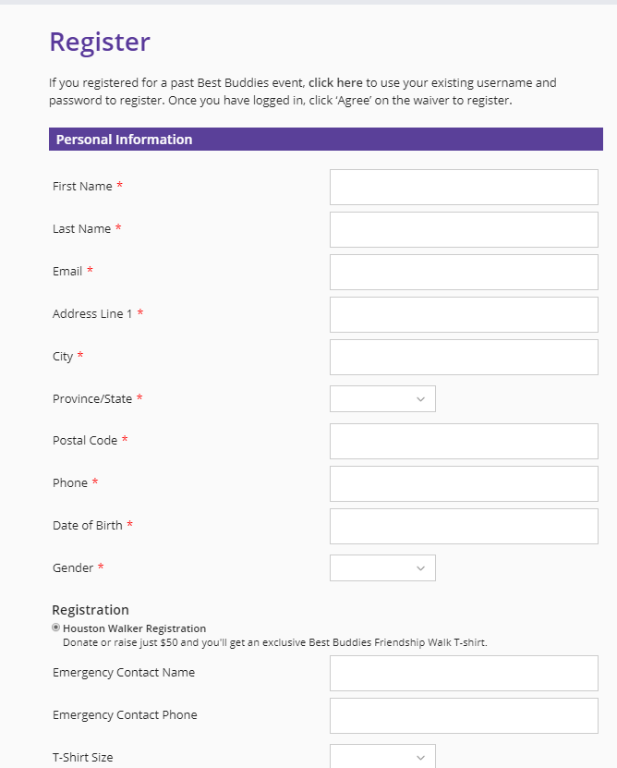

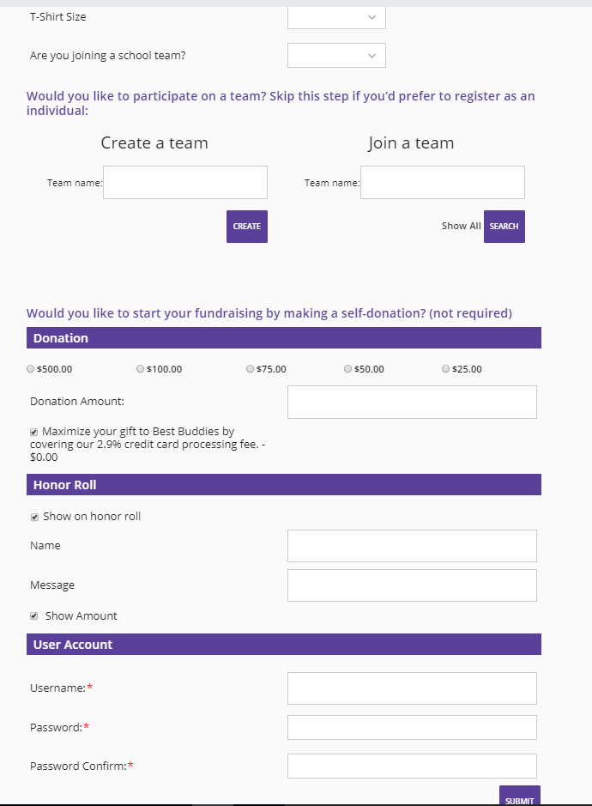

*Source: https://www.bestbuddiesfriendshipwalk.org/normal/register/#form////y*

1. Bike MS mandates the participant to enter a minimum fundraising goal of $250 before registering, which is not necessarily needed to be achieved in an event. It might be a potential reason for discouraging participants from signing up. This is optional while registering for Best buddies.

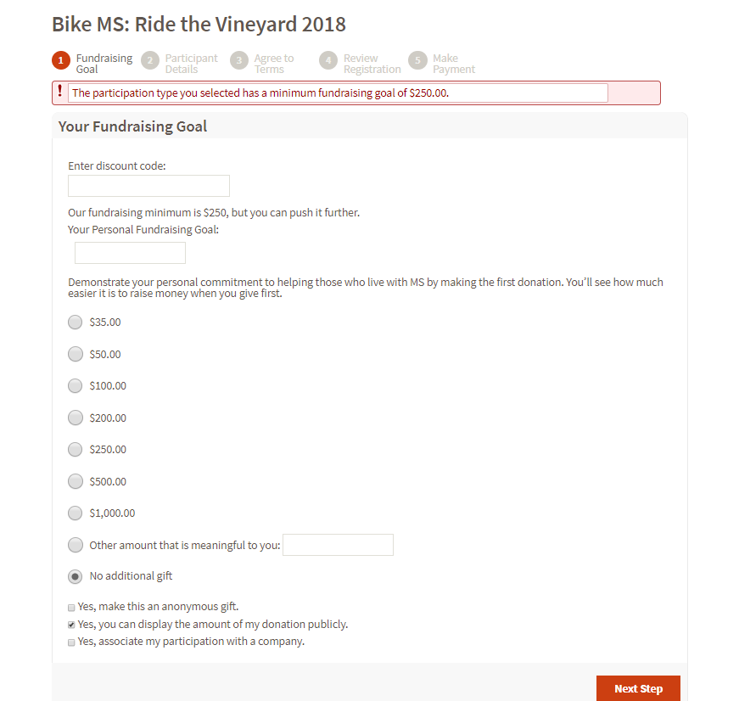

*Source:* [*http://main.nationalmssociety.org/site/PageNavigator/BIKE_HOM_splash.html*](http://main.nationalmssociety.org/site/PageNavigator/BIKE_HOM_splash.html)

Based on our following analysis, it is an issue of **conversion rate.**

# References

1. Date dimension: <https://www.mssqltips.com/sqlservertip/4054/creating-a-date-dimension-or-calendar-table-in-sql-server/>
2. Companies list: <https://datahub.io/core/s-and-p-500-companies>

<https://www.forbes.com/global2000/list/>

1. Competitors information:

* ADA Tour de cure: <https://donations.diabetes.org/site/SPageServer?pagename=TC_About_ADA>
* Best Buddies: <https://www.bestbuddies.org/about-us/annual-reports/>
* JDRF: <http://www.jdrf.org/about/>
* PedalTheCause: <https://www.pedalthecause.org/impact/>
* St. Jude Children’s Research Hospital: <https://www.stjude.org/about-st-jude.html>

1. Glossary: <http://www.rpi.edu/datawarehouse/dw-glossary.html>
2. Best Buddies Registration Form: <https://www.bestbuddiesfriendshipwalk.org/normal/register/#form////y>
3. Bike MS Registration Form: <http://main.nationalmssociety.org/site/PageNavigator/BIKE_HOM_splash.html>

# Glossary

|  |  |
| --- | --- |
| **Term** | **Definition** |
| **BI**  **Business Intelligence** | A suite of software tools used primarily by business administrative staff to navigate through the data of the data warehouse. BI tools provide functionality including managed reporting, querying, data analysis, data visualization, etc. |
| **Cube** | A multi-dimensional representation of business data in which the cells of the cube contain data measures (i.e. facts) and the edges of the cube represent the data dimensions.  Although a cube implies only 3 dimensions in geometry, a data cube may represent any number of dimensions. |
| **Data mart** | A subset of the organization's data, focused on a specific subject area or business area. |
| **Data warehouse**  **DW** | (1) A collection of data pulled together primarily from operational business systems, structured and tuned for easy access and use by consumers and analysts, especially in support of forecasting and decision-making.  (2) A subject-oriented, integrated, time-varying, non-volatile collection of data in support of the management's decision-making process. (John Inmon) |
| **Dimension** | A set of attributes, usually hierarchical, that is used to describe an organization's business by constraining and grouping facts.  Example dimensions include time, students, faculty, organization, funds, etc. |
| **ETL**  **Extraction, Transformation, Loading** | A set of back-end data staging steps that are used to (1) obtain data from operational sources (i.e. the extraction step), (2) cleanse and prepare data for import into the data warehouse (i.e. the transformation step), and (3) actually importing the transformed data into the data warehouse (i.e. the loading step). |
| **Fact** | A numeric (or other type of) data element by which an organization measures aspect of its business. The most useful facts are indeed numeric and often additive.  Example facts include dollar amounts (e.g. budget, expenditure, encumbrance, revenue), counts (e.g. headcount, credit hours), etc. |
| **Grain** | The meaning of a single record in a fact table. |
| **Metadata** | Data about data; any data maintained to support the operation or use of a data warehouse, including business names and definitions of facts, dimensions, attributes, etc. |
| **ODBC**  **Open Database Connectivity** | Often used in a Microsoft Windows environment, ODBC is a standard protocol for accessing a majority of database systems, including Oracle, Access, etc. |
| **OLAP**  **On-Line Analytical Processing** | A category of database software systems that primarily involves aggregating large amounts of data from a data warehouse environment. |
| **OLTP**  **On-Line Transactional Processing** | A category of database software systems that typically involves processing transactions in real time. |
| **RDBMS**  **Relational Database Management System** | A database (e.g. Oracle) in which information is represented via tables and relationships between such tables. The term RDBMS is also often used to refer to software that helps to administer a database. |
| **Accumulating snapshot** | Describes a fact table that represents the state of affairs at the end of each time period. |
| **Star schema** | A collection of dimensions joined together with a single fact table that is used to construct queries against a data warehouse. |
| **SSIS package**  **(SQL Server Integration Services)** | SSIS is a platform for data integration and workflow applications. It features a data warehousing tool used for data extraction, transformation, and loading (ETL). The tool may also be used to automate maintenance of SQL Server databases and updates to multidimensional cube data. SSIS packages are a collection of data flows. |

Source: <http://www.rpi.edu/datawarehouse/dw-glossary.html>

# 12. Peer Evaluation

**Divyesh Batra**

|  |  |  |  |  |  |
| --- | --- | --- | --- | --- | --- |
| **Criteria** | **Maximum Points** | **Harikrishnan Subramanyan** | **Nupur Sinha** | **Tanushree Kothari** | **Tsai Mei Chen** |
| Shows up to meetings | 10 | 10 | 10 | 10 | 10 |
| Demonstrates respect for other team members | 10 | 10 | 10 | 10 | 10 |
| Level of contribution to the team | 20 | 20 | 20 | 20 | 20 |
| Accepts and shares team responsibilities | 10 | 10 | 10 | 10 | 10 |
| Actively contributes to project completion | 15 | 15 | 15 | 15 | 15 |
| Willing to help other team members | 10 | 10 | 10 | 10 | 10 |
| Has a positive attitude towards team | 10 | 10 | 10 | 10 | 10 |
| Actively contributes to the preparation of the report | 15 | 15 | 15 | 15 | 15 |
| Total individual scores | 100 | 100 | 100 | 100 | 100 |

**Harikrishnan Subramanyan**

|  |  |  |  |  |  |
| --- | --- | --- | --- | --- | --- |
| **Criteria** | **Maximum Points** | **Divyesh Batra** | **Nupur Sinha** | **Tanushree Kothari** | **Tsai Mei Chen** |
| Shows up to meetings | 10 | 10 | 10 | 10 | 10 |
| Demonstrates respect for other team members | 10 | 10 | 10 | 10 | 10 |
| Level of contribution to the team | 20 | 20 | 20 | 20 | 20 |
| Accepts and shares team responsibilities | 10 | 10 | 10 | 10 | 10 |
| Actively contributes to project completion | 15 | 15 | 15 | 15 | 15 |
| Willing to help other team members | 10 | 10 | 10 | 10 | 10 |
| Has a positive attitude towards team | 10 | 10 | 10 | 10 | 10 |
| Actively contributes to the preparation of the report | 15 | 15 | 15 | 15 | 15 |
| Total individual scores | 100 | 100 | 100 | 100 | 100 |

**Nupur Sinha**

|  |  |  |  |  |  |
| --- | --- | --- | --- | --- | --- |
| **Criteria** | **Maximum Points** | **Divyesh Batra** | **Harikrishnan Subramanyan** | **Tanushree Kothari** | **Tsai Mei Chen** |
| Shows up to meetings | 10 | 10 | 10 | 10 | 10 |
| Demonstrates respect for other team members | 10 | 10 | 10 | 10 | 10 |
| Level of contribution to the team | 20 | 20 | 20 | 20 | 20 |
| Accepts and shares team responsibilities | 10 | 10 | 10 | 10 | 10 |
| Actively contributes to project completion | 15 | 15 | 15 | 15 | 15 |
| Willing to help other team members | 10 | 10 | 10 | 10 | 10 |
| Has a positive attitude towards team | 10 | 10 | 10 | 10 | 10 |
| Actively contributes to the preparation of the report | 15 | 15 | 15 | 15 | 15 |
| Total individual scores | 100 | 100 | 100 | 100 | 100 |

**Tanushree Kothari**

|  |  |  |  |  |  |
| --- | --- | --- | --- | --- | --- |
| **Criteria** | **Maximum Points** | **Divyesh Batra** | **Harikrishnan Subramanyan** | **Nupur Sinha** | **Tsai Mei Chen** |
| Shows up to meetings | 10 | 10 | 10 | 10 | 10 |
| Demonstrates respect for other team members | 10 | 10 | 10 | 10 | 10 |
| Level of contribution to the team | 20 | 20 | 20 | 20 | 20 |
| Accepts and shares team responsibilities | 10 | 10 | 10 | 10 | 10 |
| Actively contributes to project completion | 15 | 15 | 15 | 15 | 15 |
| Willing to help other team members | 10 | 10 | 10 | 10 | 10 |
| Has a positive attitude towards team | 10 | 10 | 10 | 10 | 10 |
| Actively contributes to the preparation of the report | 15 | 15 | 15 | 15 | 15 |
| Total individual scores | 100 | 100 | 100 | 100 | 100 |

**Tsai Mei Chen**

|  |  |  |  |  |  |
| --- | --- | --- | --- | --- | --- |
| **Criteria** | **Maximum Points** | **Divyesh Batra** | **Harikrishnan Subramanyan** | **Nupur Sinha** | **Tanushree Kothari** |
| Shows up to meetings | 10 | 10 | 10 | 10 | 10 |
| Demonstrates respect for other team members | 10 | 10 | 10 | 10 | 10 |
| Level of contribution to the team | 20 | 20 | 20 | 20 | 20 |
| Accepts and shares team responsibilities | 10 | 10 | 10 | 10 | 10 |
| Actively contributes to project completion | 15 | 15 | 15 | 15 | 15 |
| Willing to help other team members | 10 | 10 | 10 | 10 | 10 |
| Has a positive attitude towards team | 10 | 10 | 10 | 10 | 10 |
| Actively contributes to the preparation of the report | 15 | 15 | 15 | 15 | 15 |
| Total individual scores | 100 | 100 | 100 | 100 | 100 |

1. <http://www.teradatauniversitynetwork.com/Community/Student-Competitions/2018/Data-Challenge/Business-Questions/>
2. <https://en.wikipedia.org/wiki/National_Multiple_Sclerosis_Society>
3. <https://www.medicalnewstoday.com/articles/37556.php>
4. https://www.nationalmssociety.org/NationalMSSociety/media/MSNationalFiles/Financials/FY16_Annual_Progress_Report_1.pdf?ext=.pdf
5. <https://multiplesclerosisnewstoday.com/multiple-sclerosis-overview/>
6. <https://multiplesclerosisnewstoday.com/2017/11/20/nearly-1-million-americans-have-multiple-sclerosis-nmss-prevalence-study-finds/>
7. https://www.nationalmssociety.org/NationalMSSociety/media/MSNationalFiles/Financials/FY16_Annual_Progress_Report_1.pdf?ext=.pdf
8. <https://www.forbes.com/global2000/list/>
9. <https://datahub.io/core/s-and-p-500-companies>
10. <https://donations.diabetes.org/site/SPageServer?pagename=TC_About_ADA>
11. <https://www.bestbuddies.org/about-us/annual-reports/>
12. <http://www.jdrf.org/about/>
13. <https://www.pedalthecause.org/impact/>
14. <https://www.stjude.org/about-st-jude.html>